**Classification –Machine Learning Algorithms**

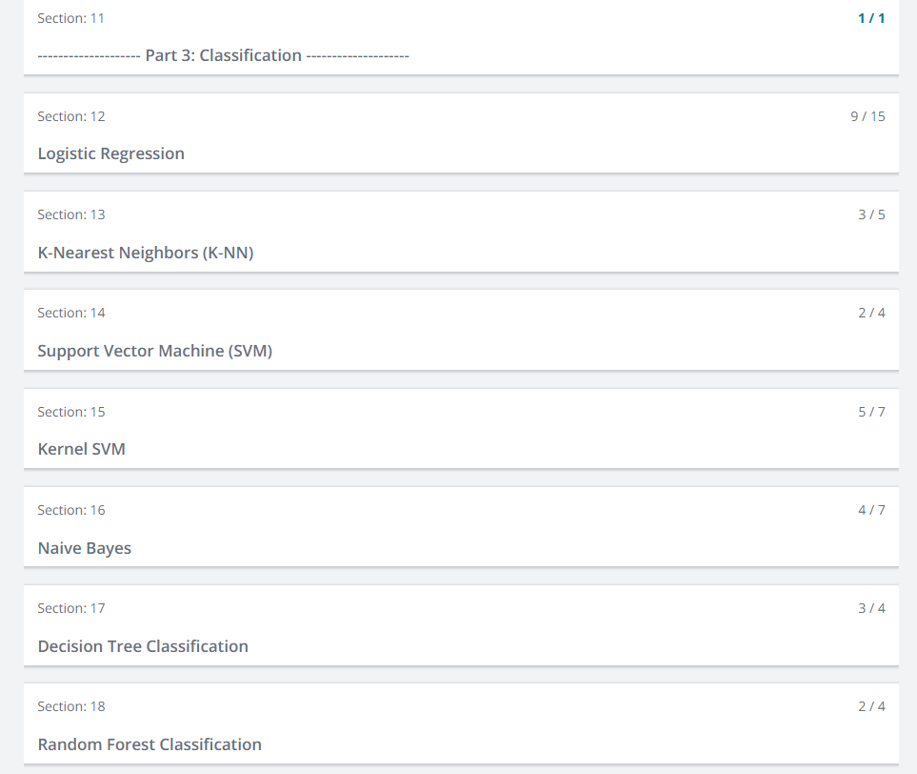

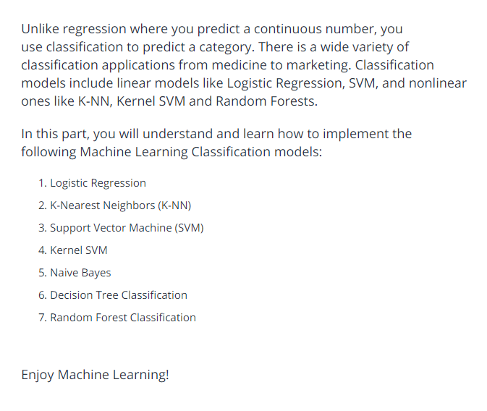

**Logistic Regression:**

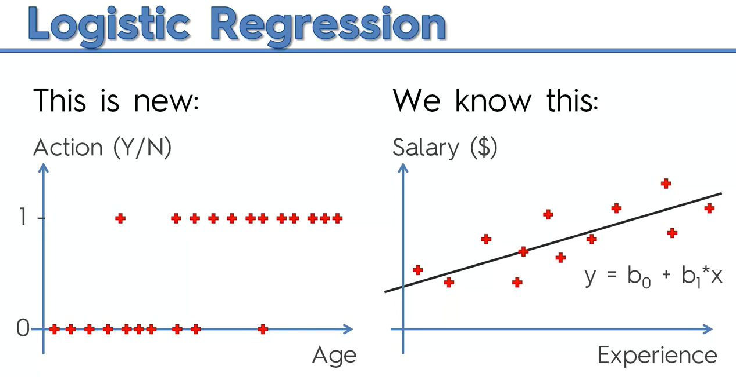

There is some correlation to predict whether customer will buy clothes or not.

If we use linear regression completely, it won’t work.

Take the probability in logistic regression that will help us to solve the problem.

We are modifying linear regression , since there is no >100% and <0%.

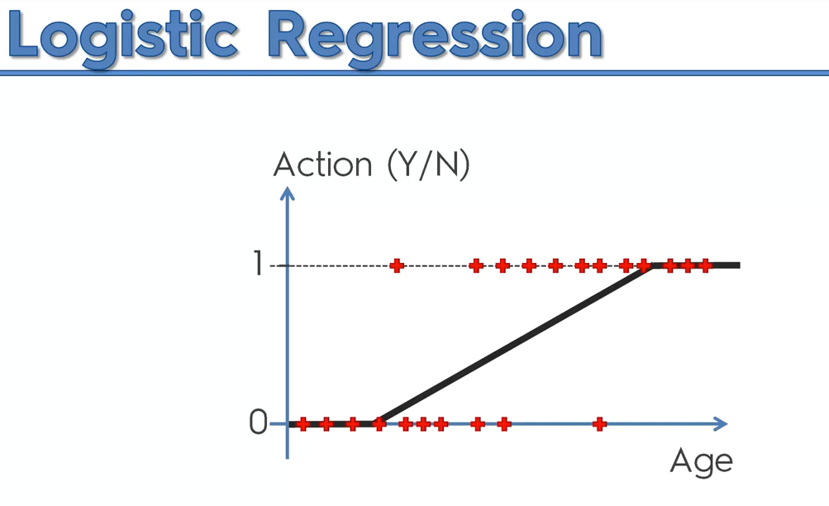

The green box is logistic regression

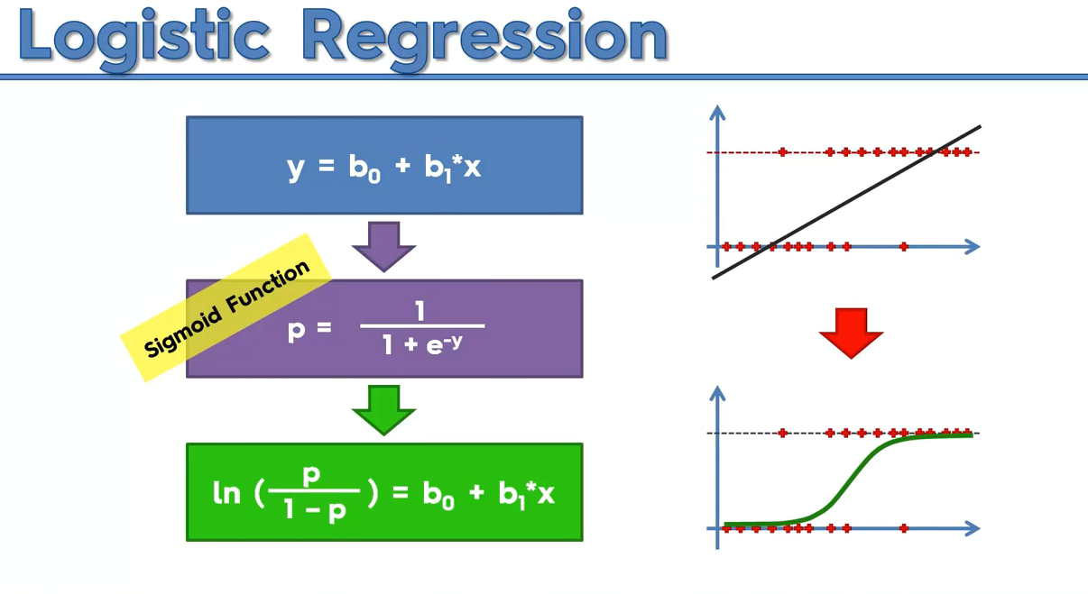

Explanation:

Step 1:

P^ means we are predicting the probability.

Green🡪fitted value

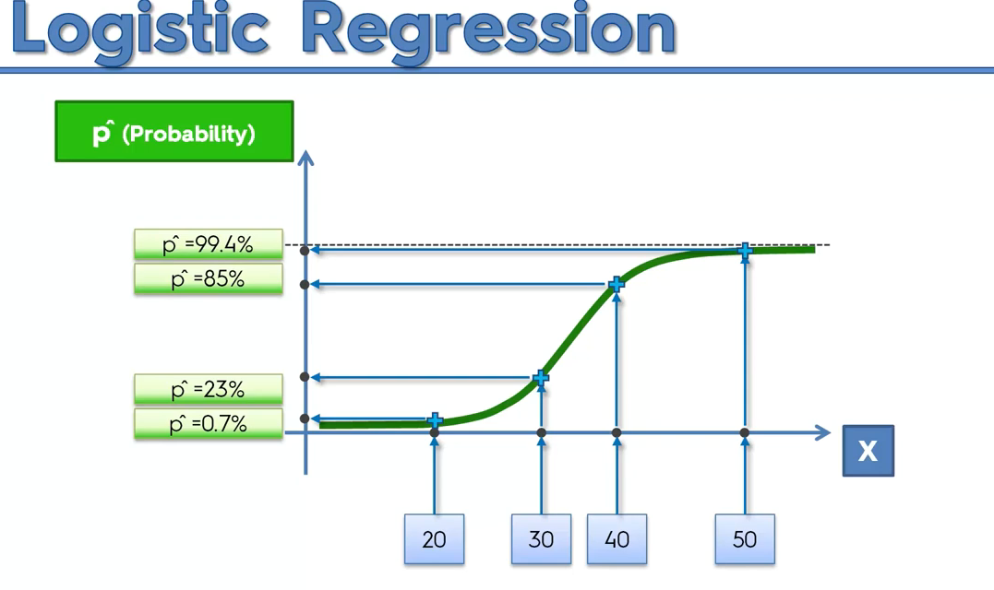

To Predict y^(Predicted Dependent variable),

We will select 50 %, below means 0, greater than 50% then 1.

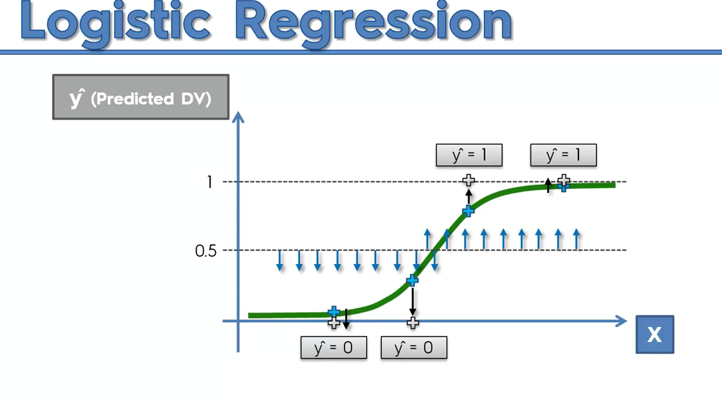

It is also exactly works like linear regression,

* In linear there will be scatter points , we will use slope line
* In classification, we will be predicting binary values, hence we modify the linear regression formula accordingly to predict the probability.
* 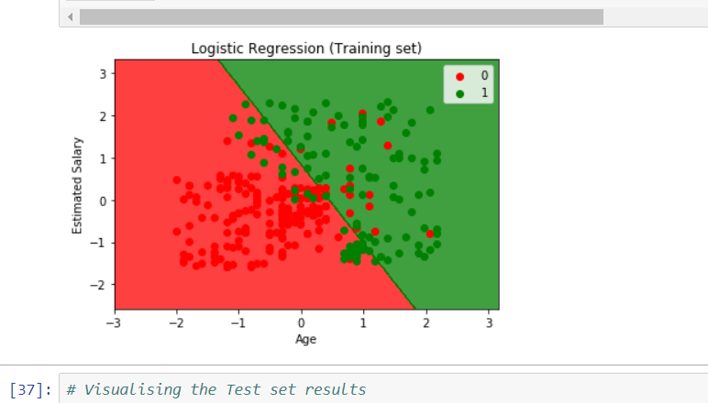

**K-NN**

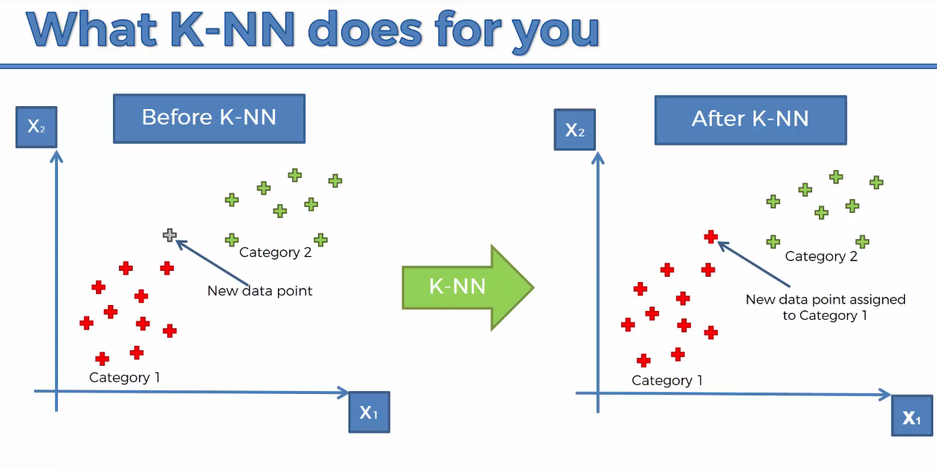

K=5 is default

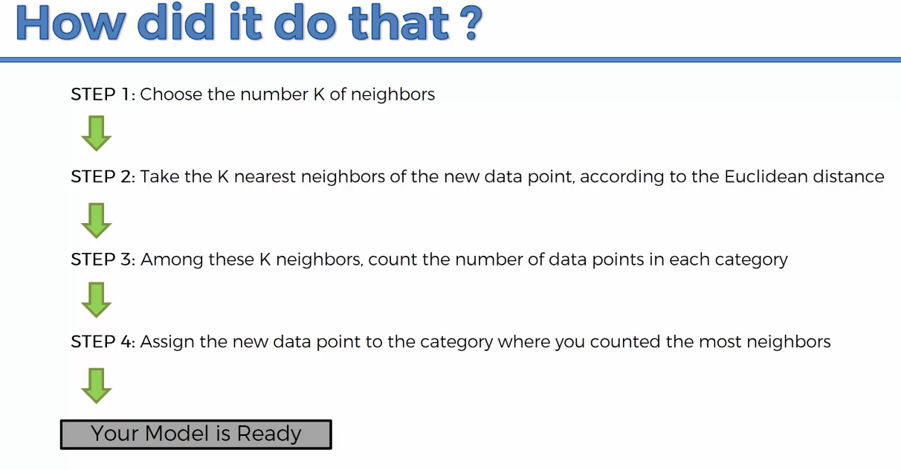

What is Euclidean distance?

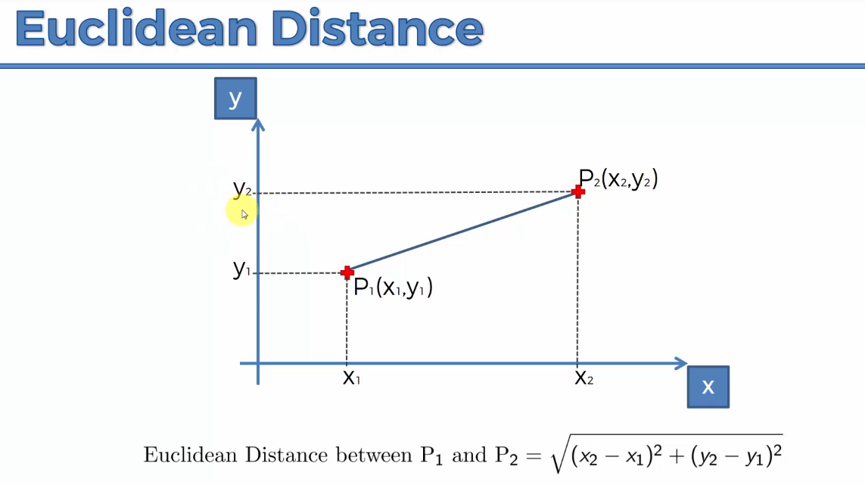

Ie distance between two points.

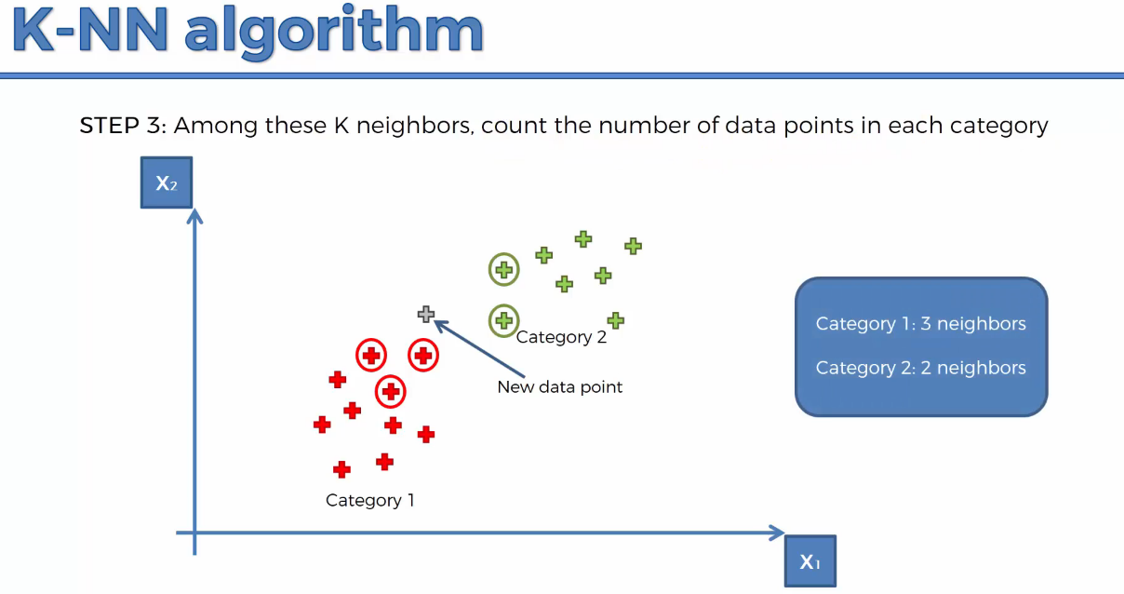

Hence the new data point is assigned as red.

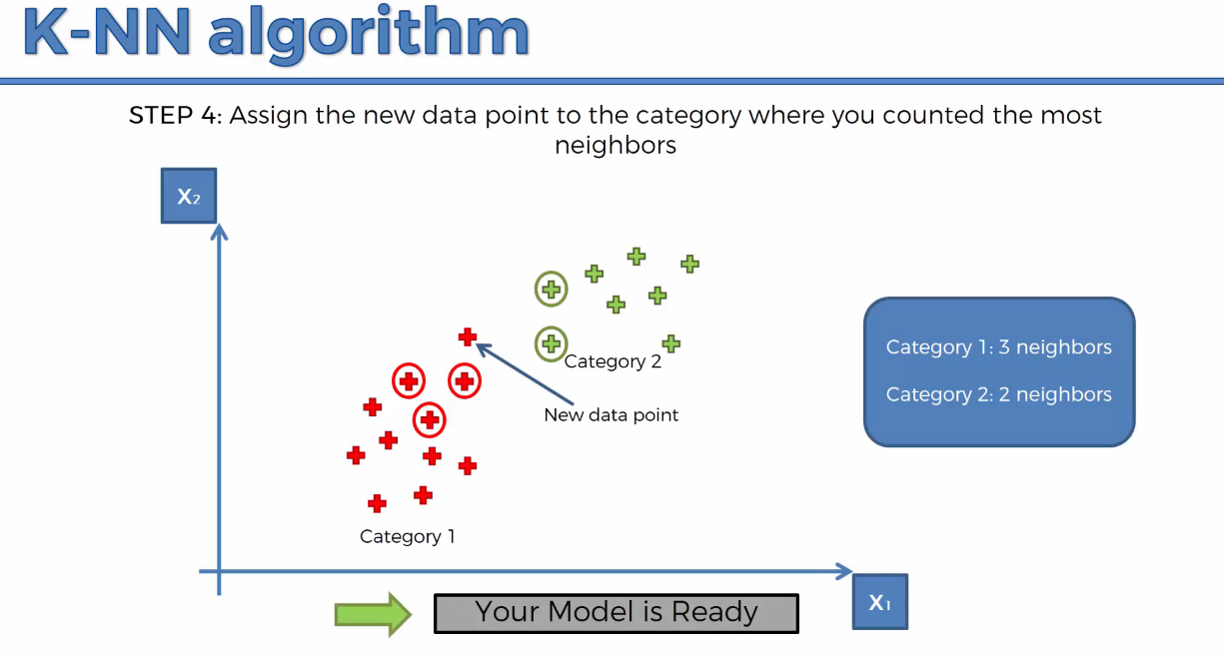

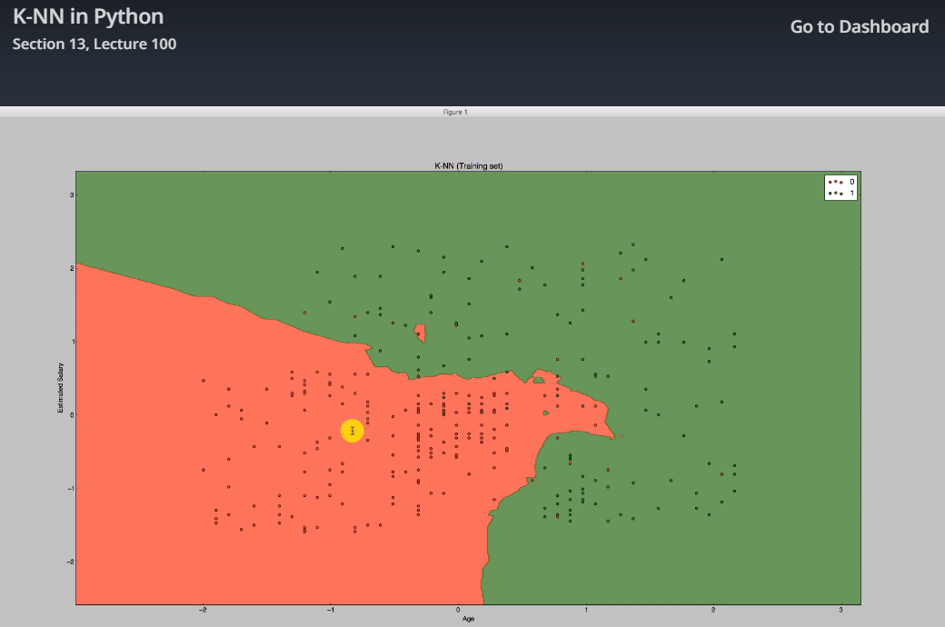

**Support Vector machine-Classifier(linear classifier)**

**kernal can be linear or rbf to make SVM linear or non-linear**

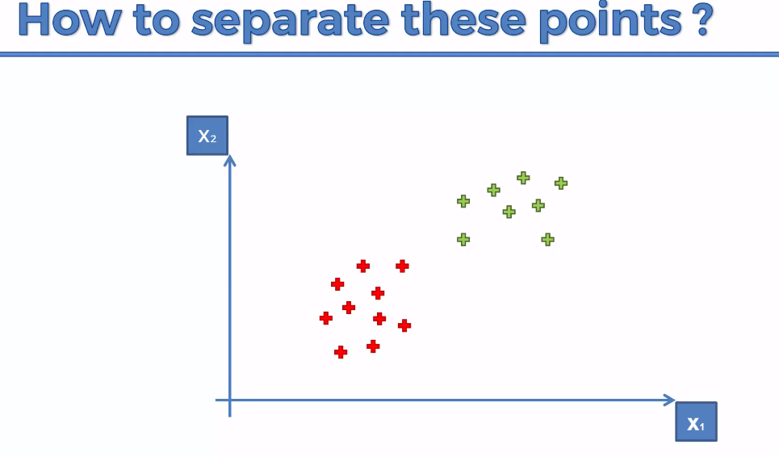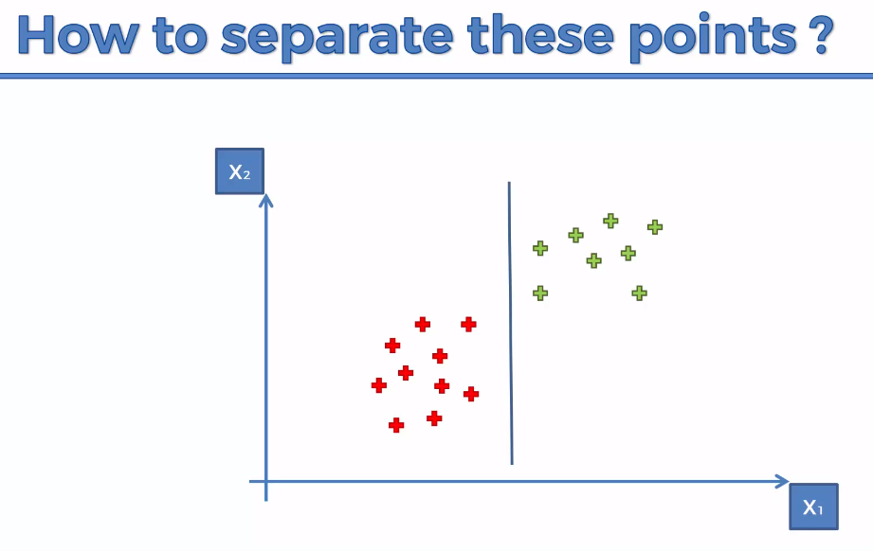

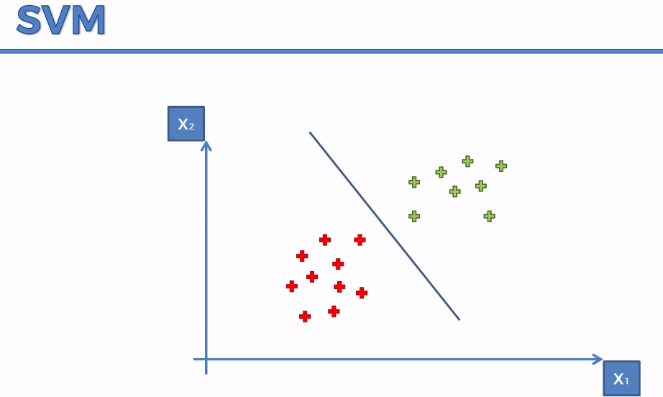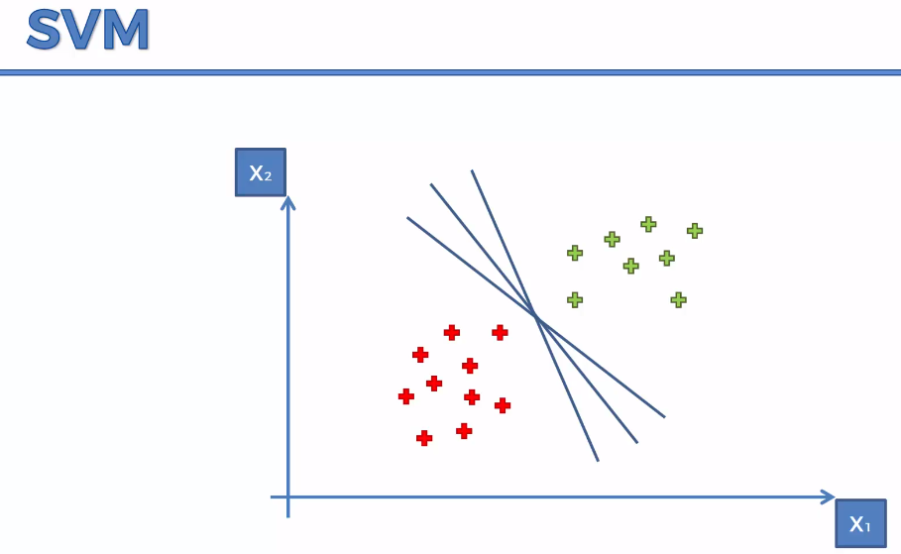

We have to find the optimal line.

Sum of the two line distance should be maximum.

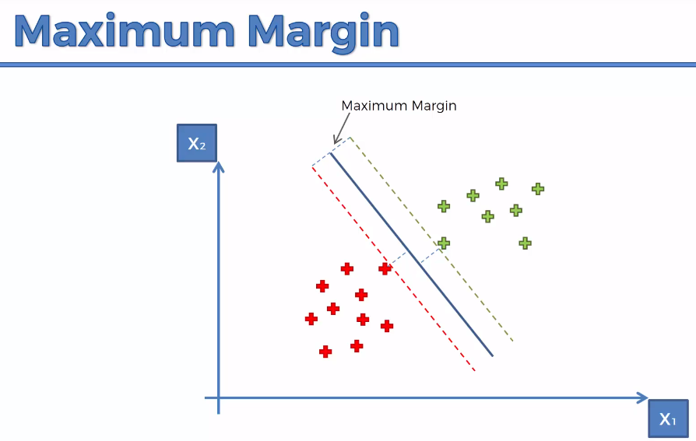 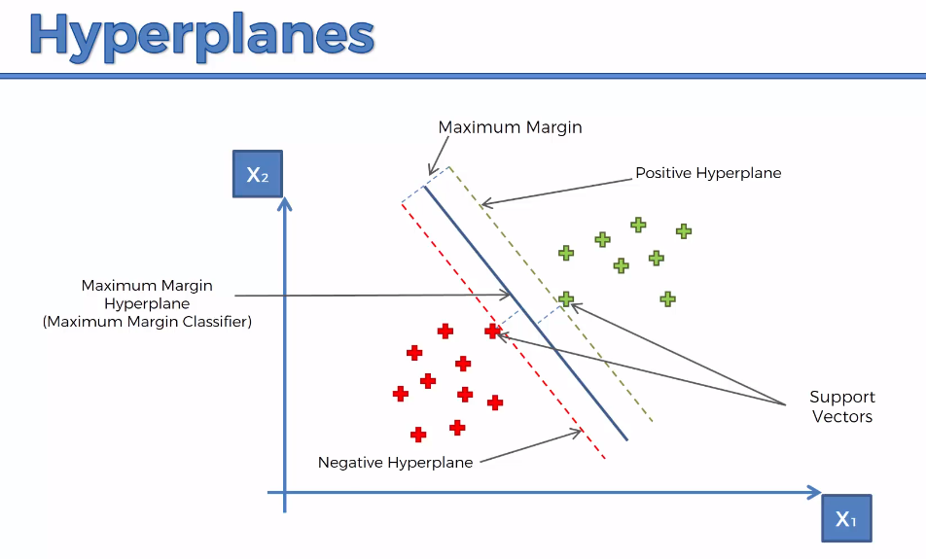

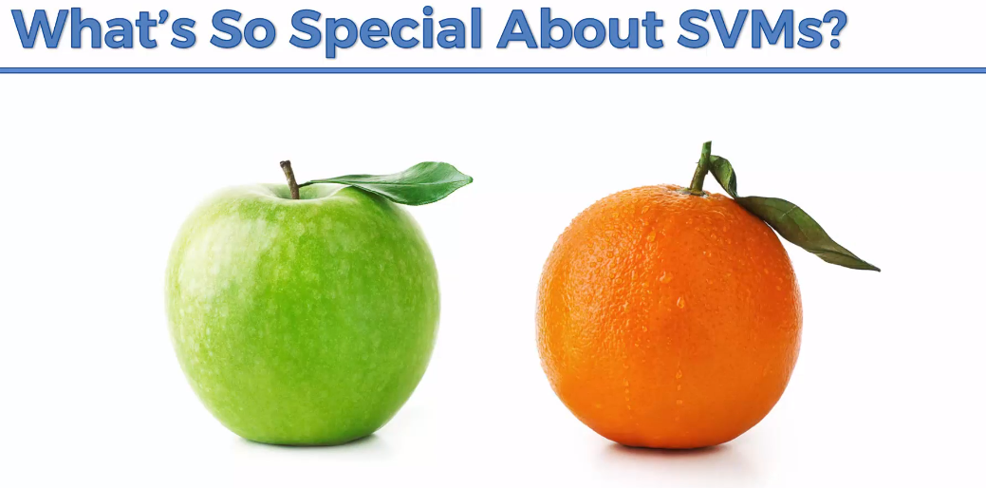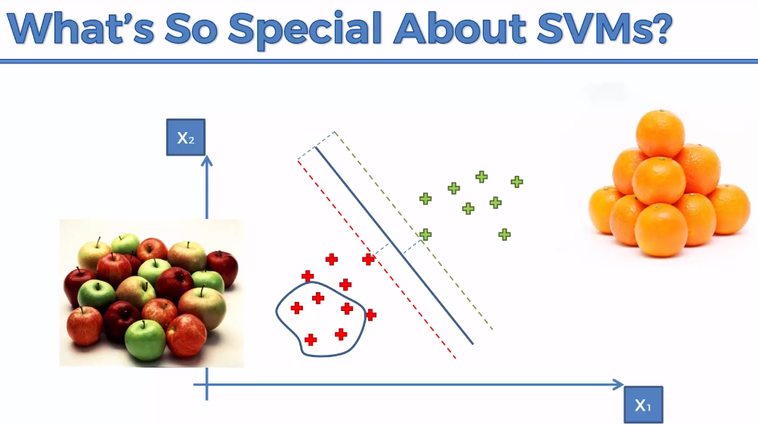

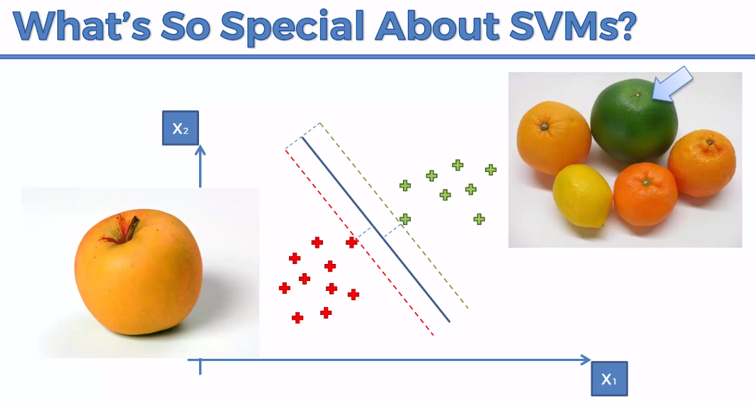

**Result:**

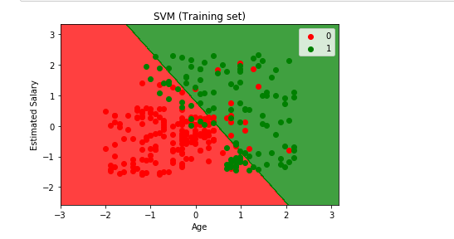

**Kernal SVM**

To handle the below scenario,

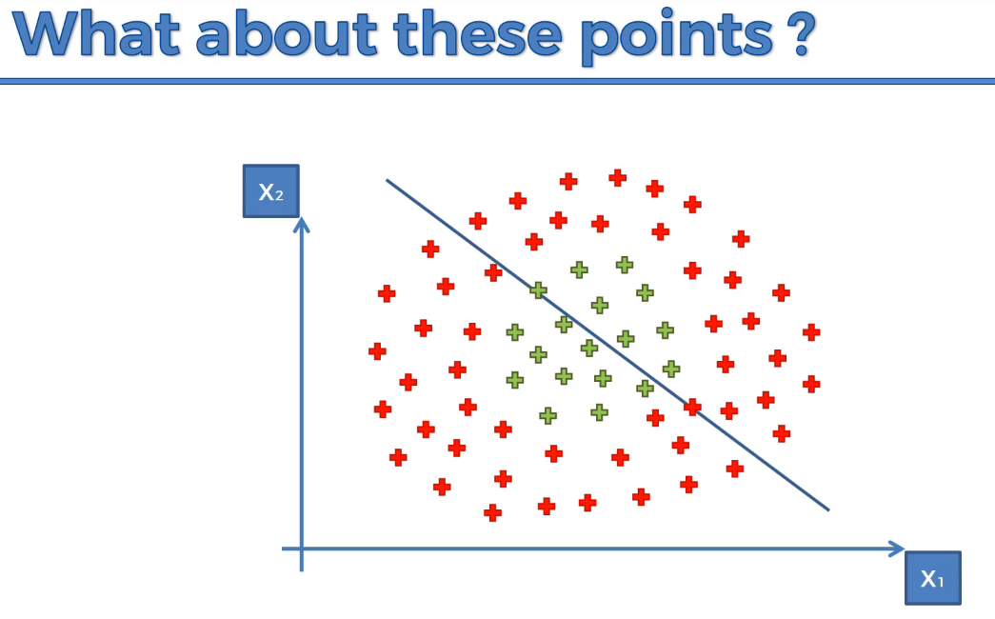

The above approach will fail if we follow linear SVM

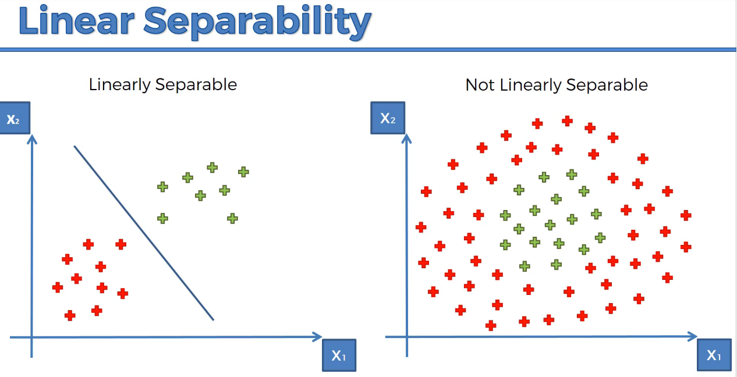

**A Higher – Dimensional Space.**

**1-D**

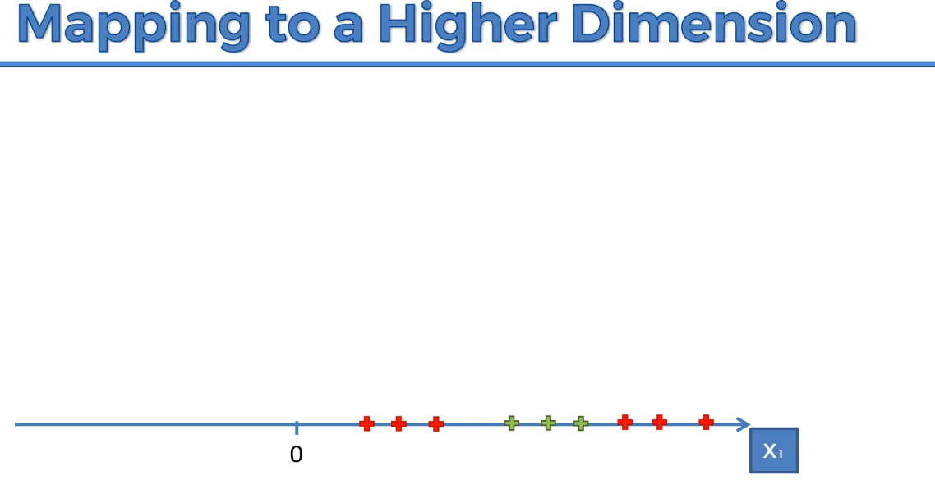

It is non-linearly separable dataset, so we are going to increase the dimensionality

Subtract 5,

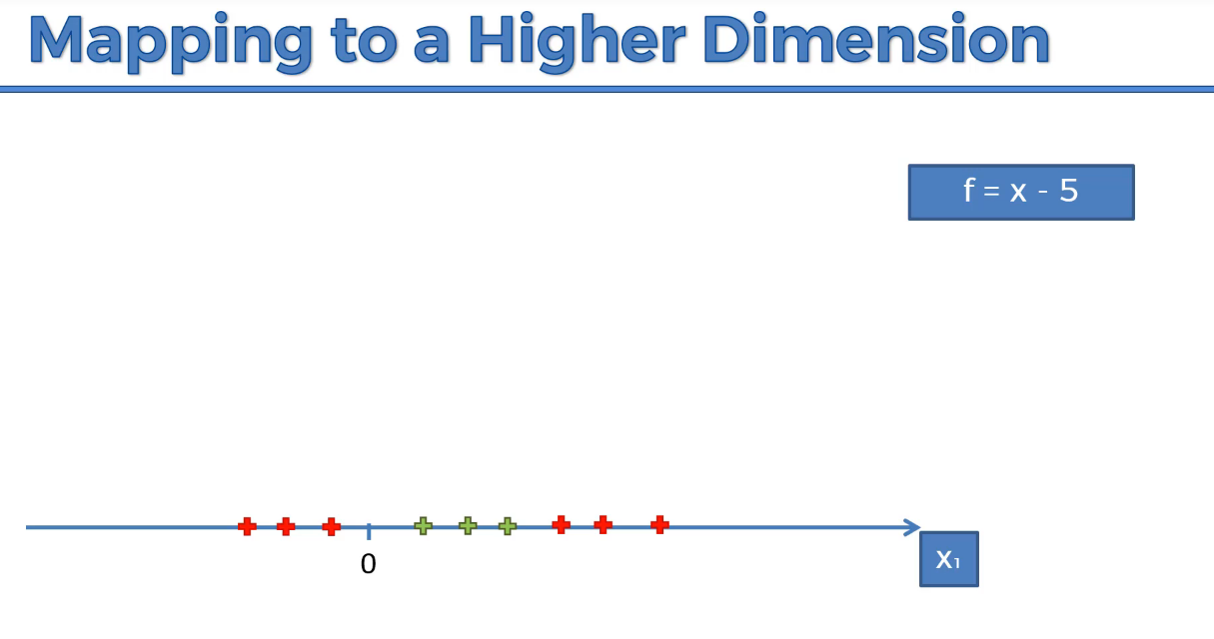

Square with 2

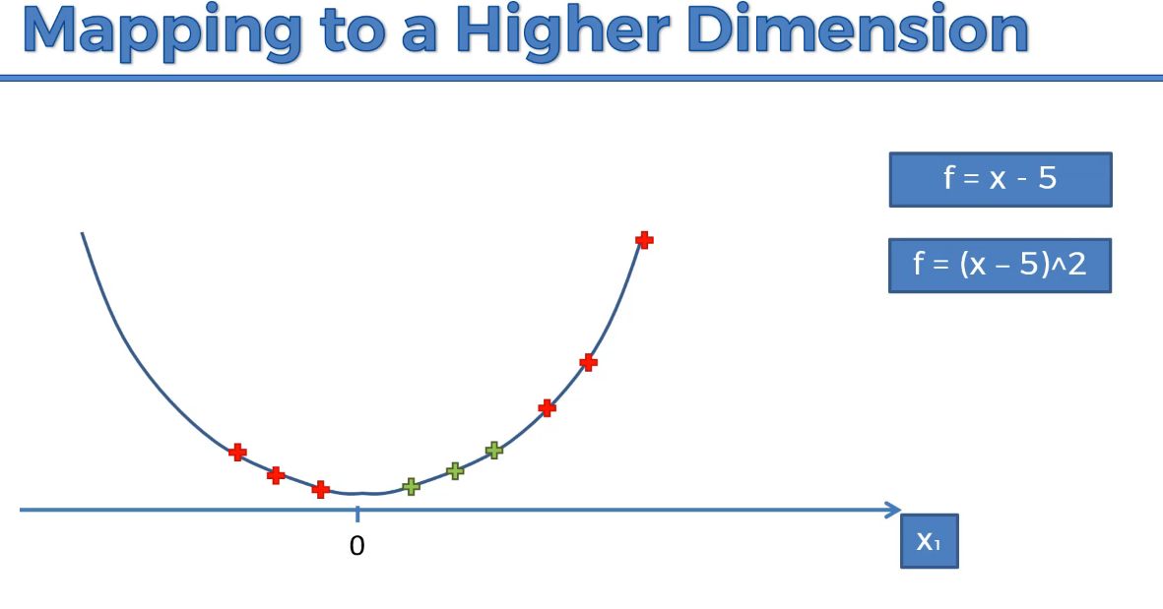

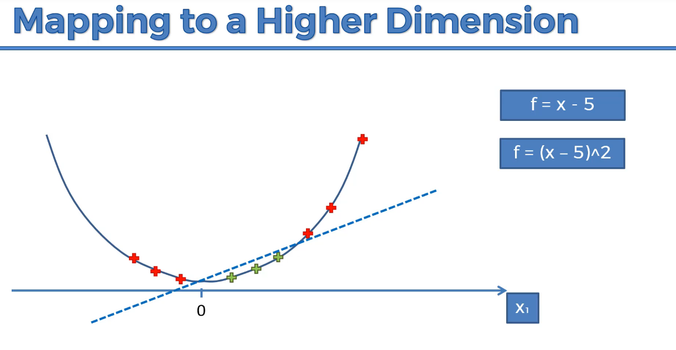

We are able to separate red and green elements.

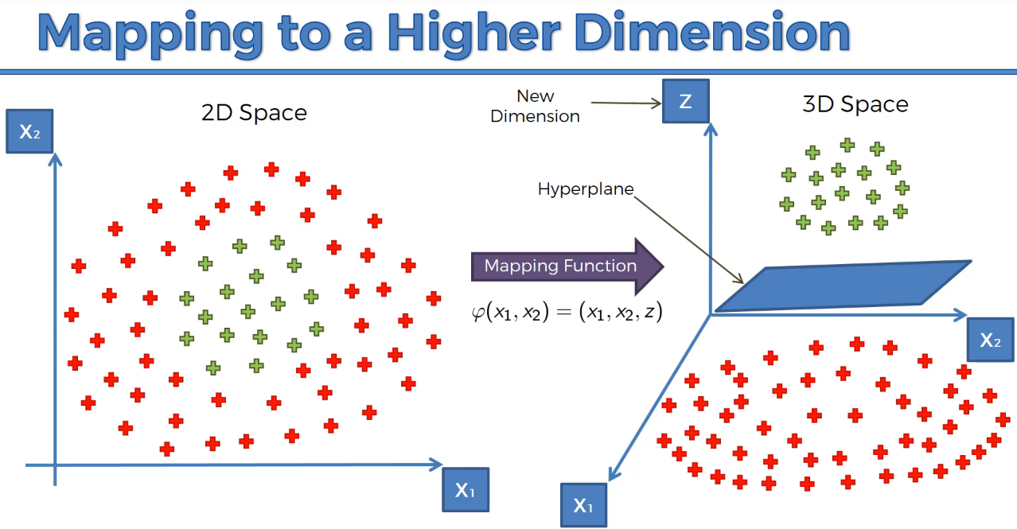

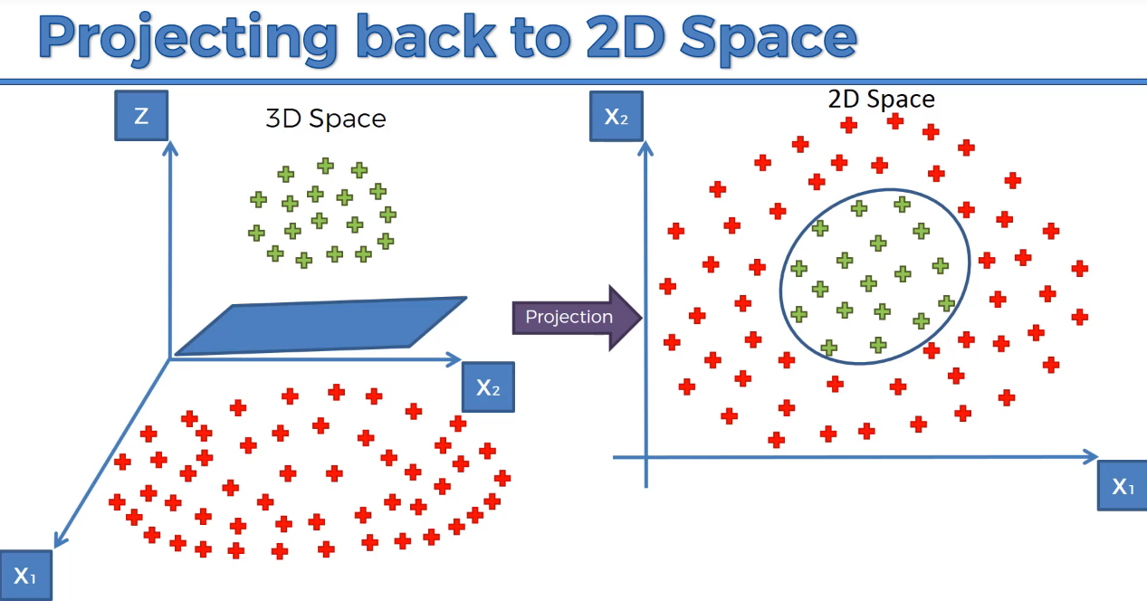

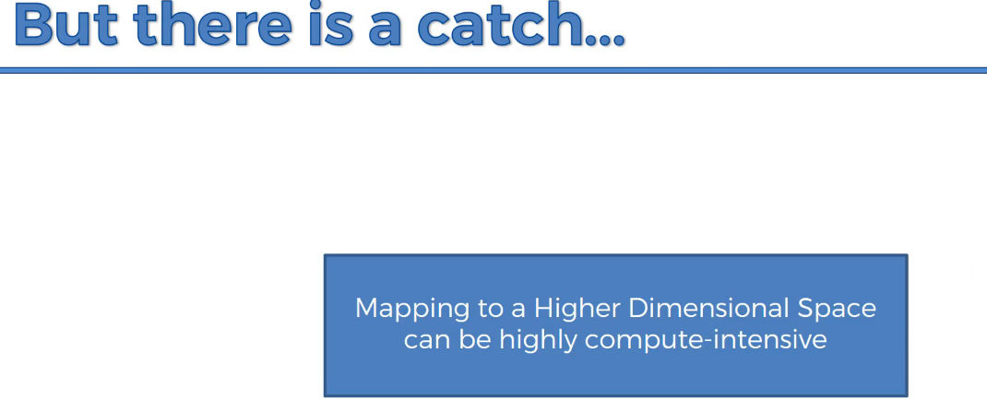

Therefore the approach it is not efficient. It will cause lot of delay. Hence we use Kernal

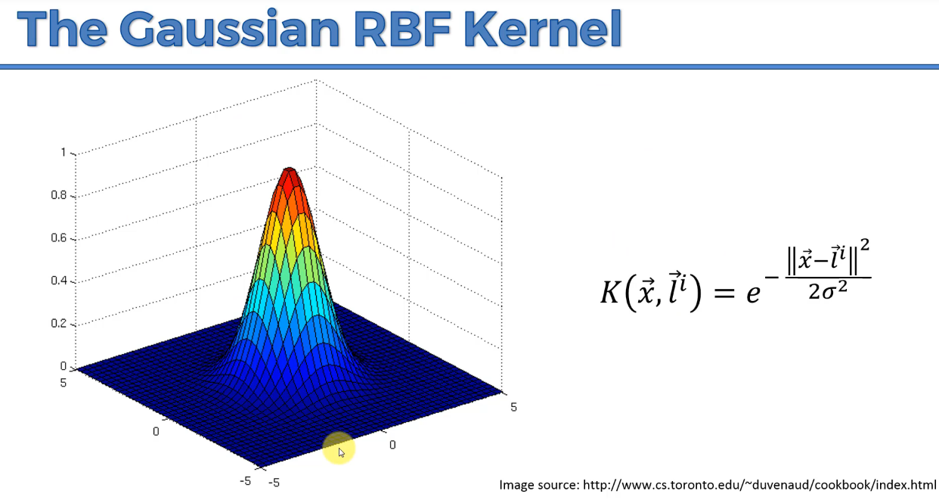

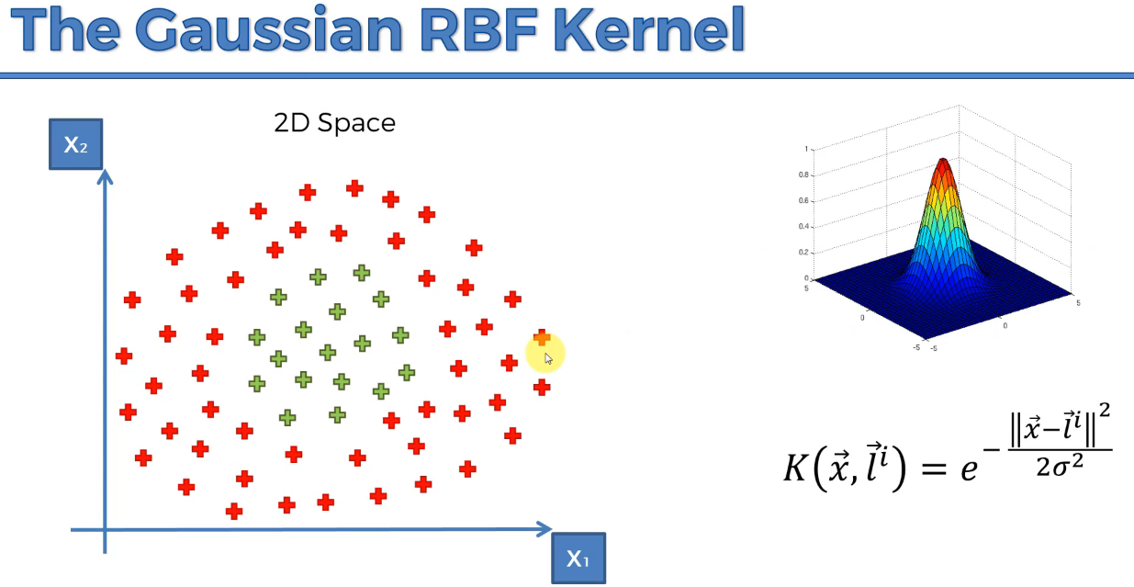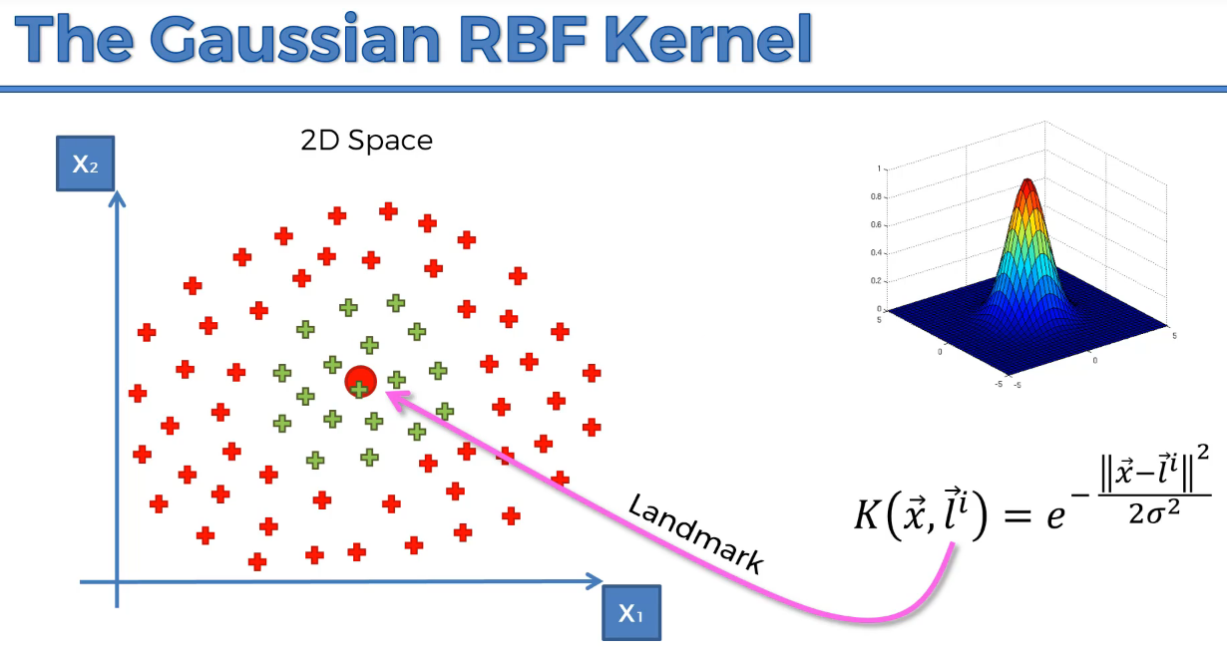

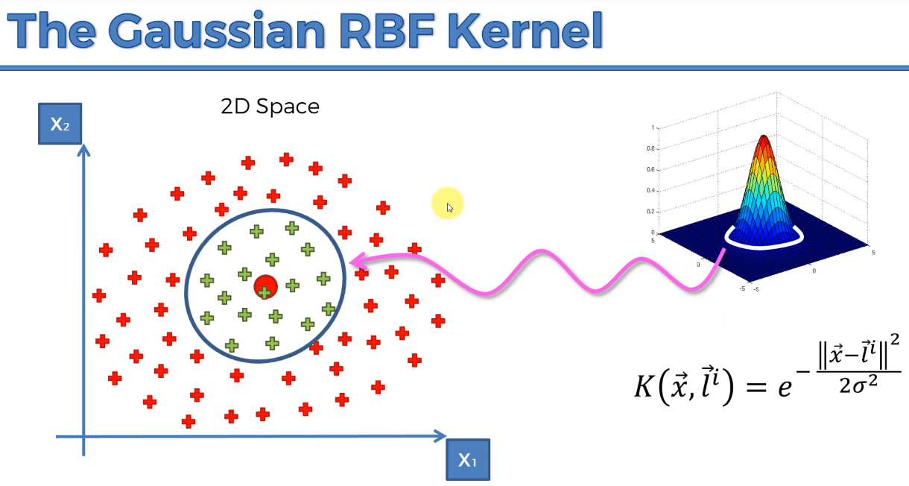

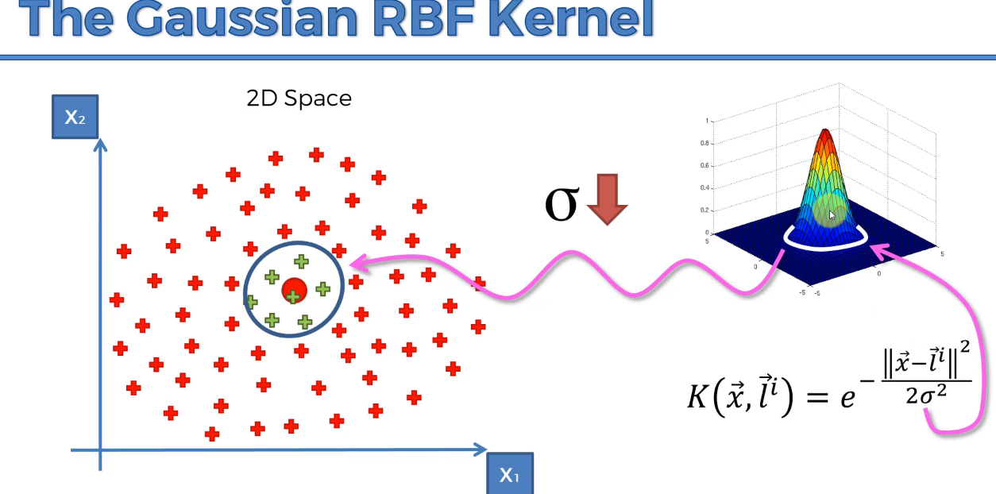

Gaussian RBF kernel can able to compute non-linear datasets, without changing the dimensionality that will reduce the efficiency.

If we have the below problem, change the formula.

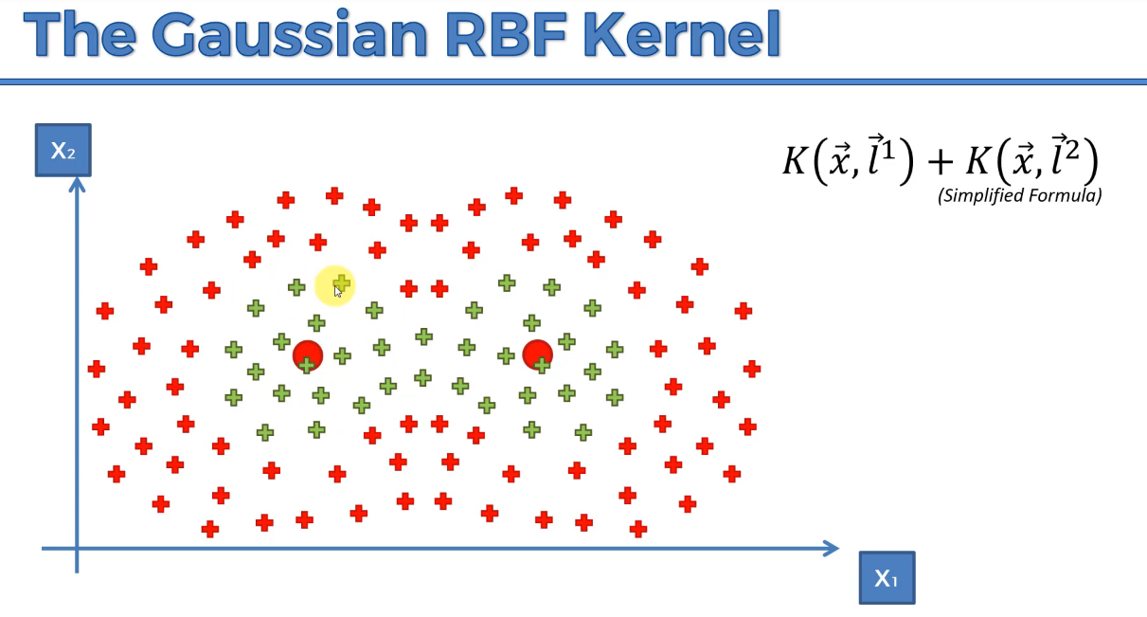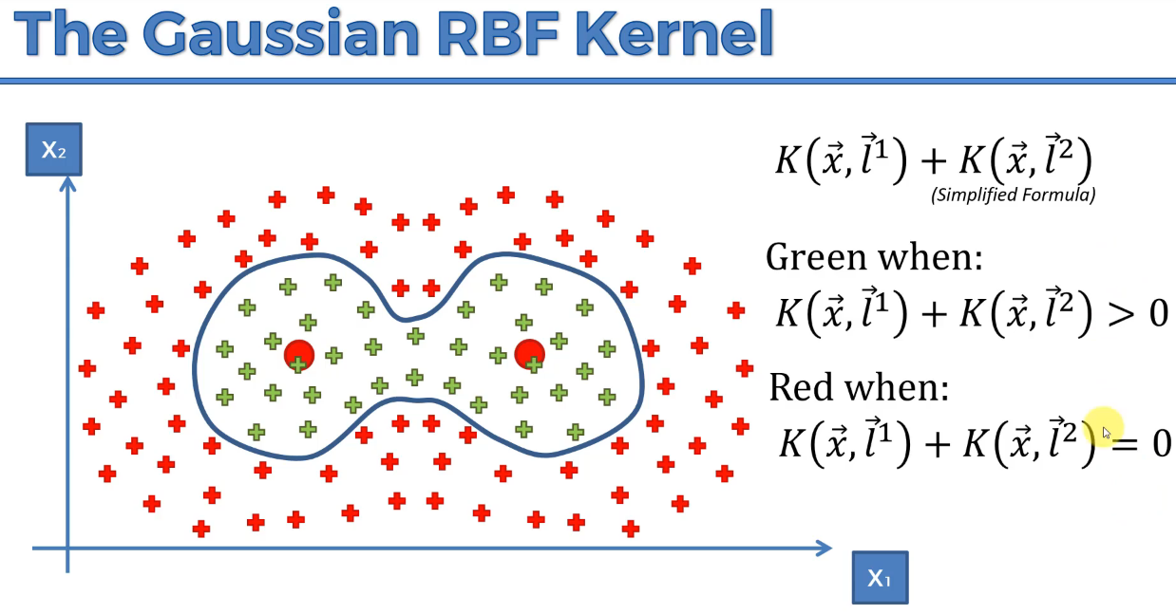

**TYPES of Kernel Functions:**

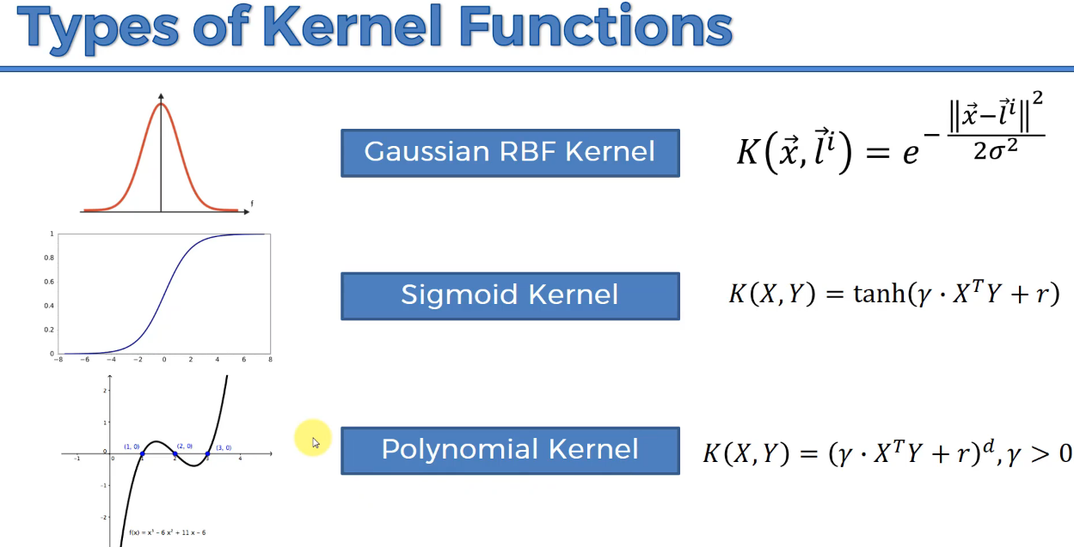

**Bayes’ Theorem**

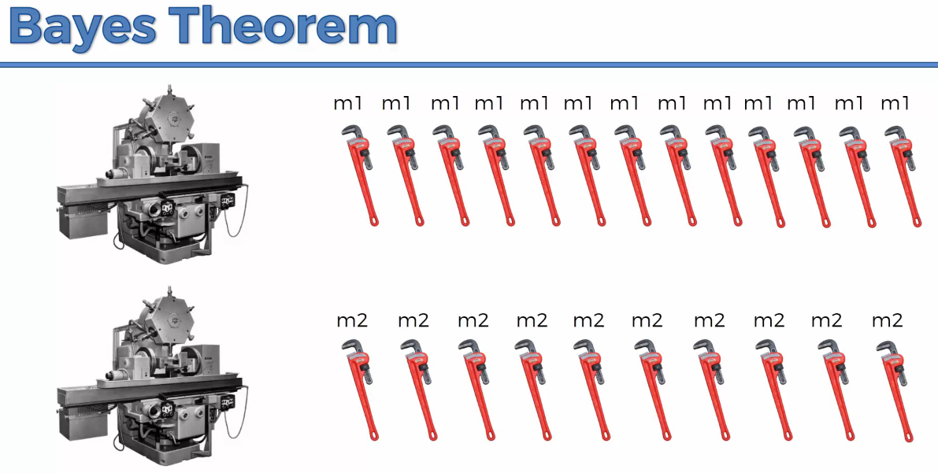

The worker has to pick the defective spanners

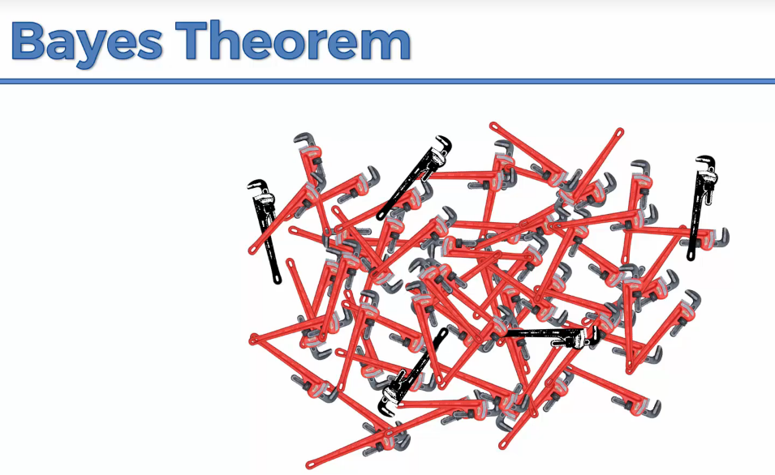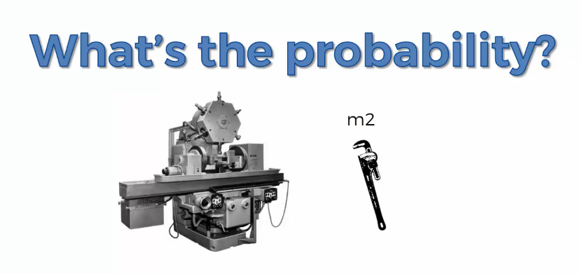

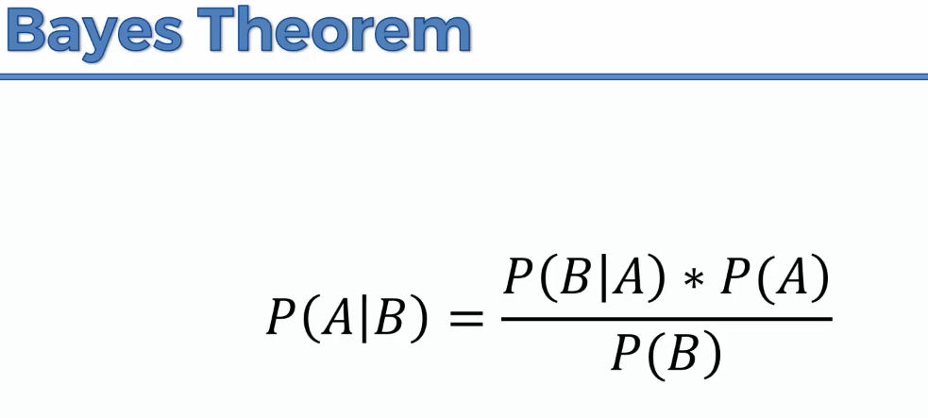

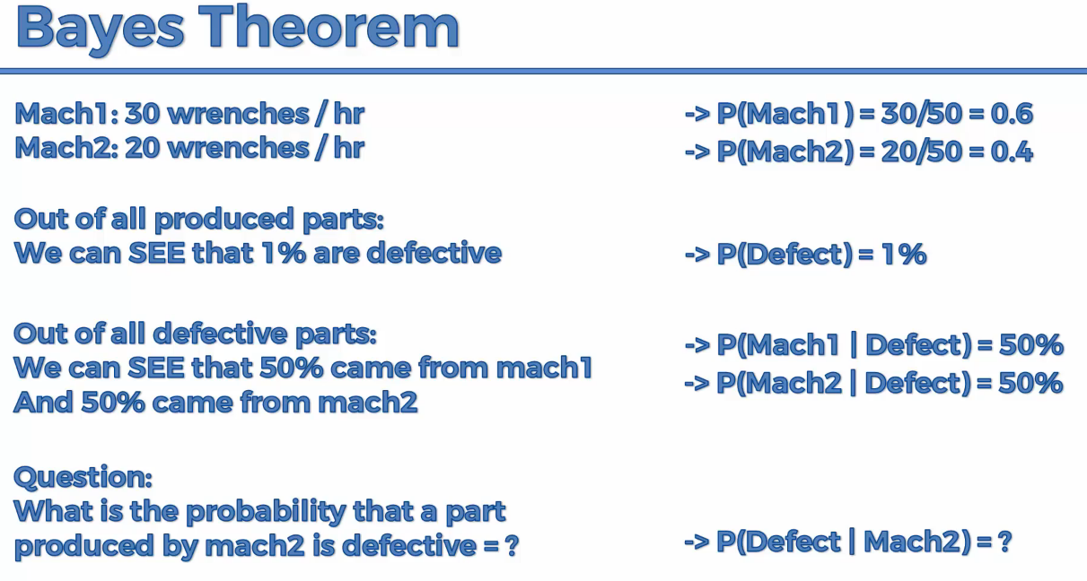

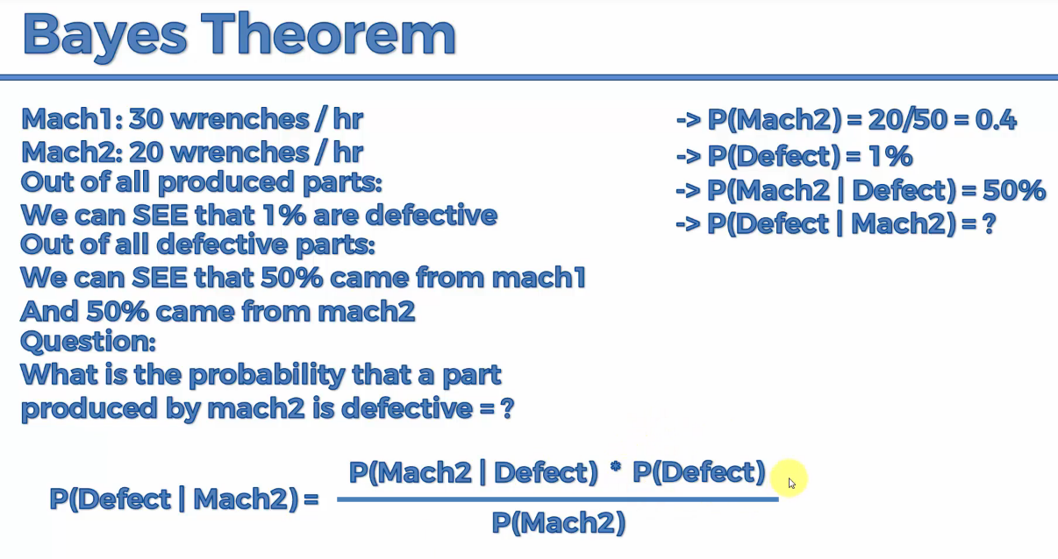

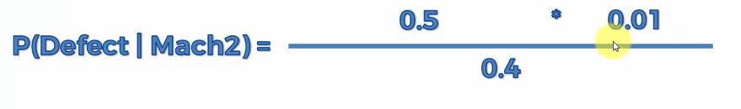

**=0.0125=1.25%**

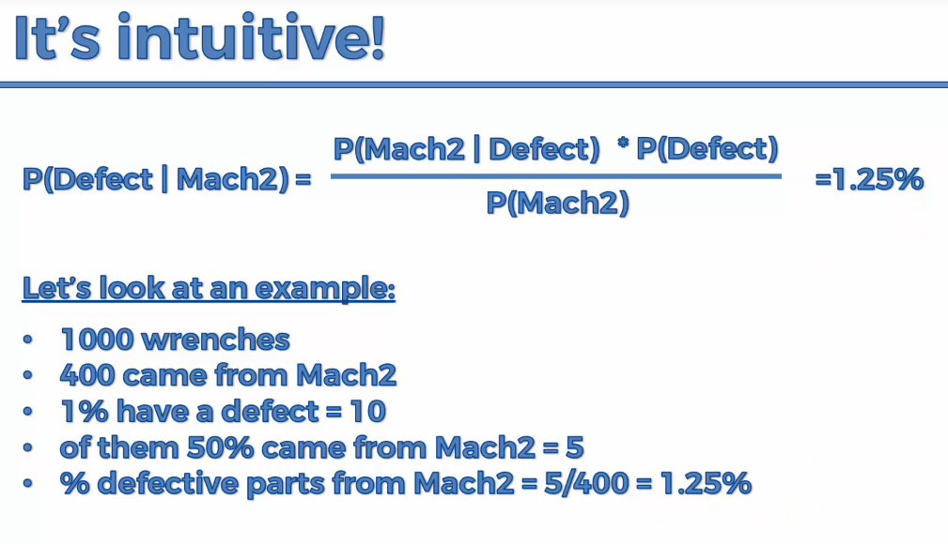

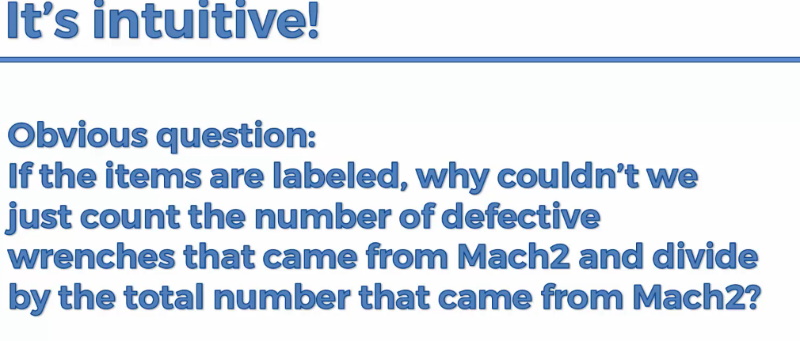

**It is time consuming to check it manually**

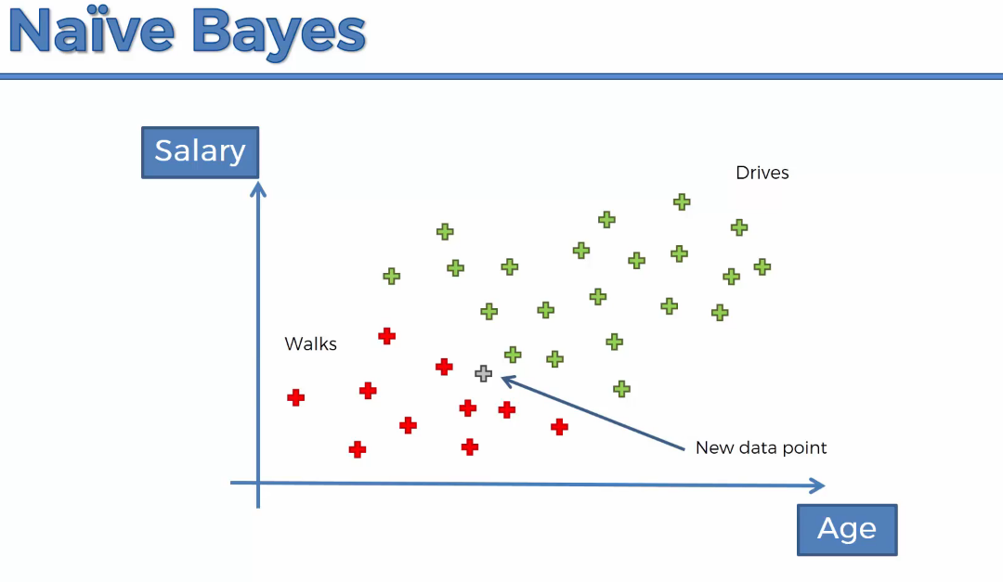

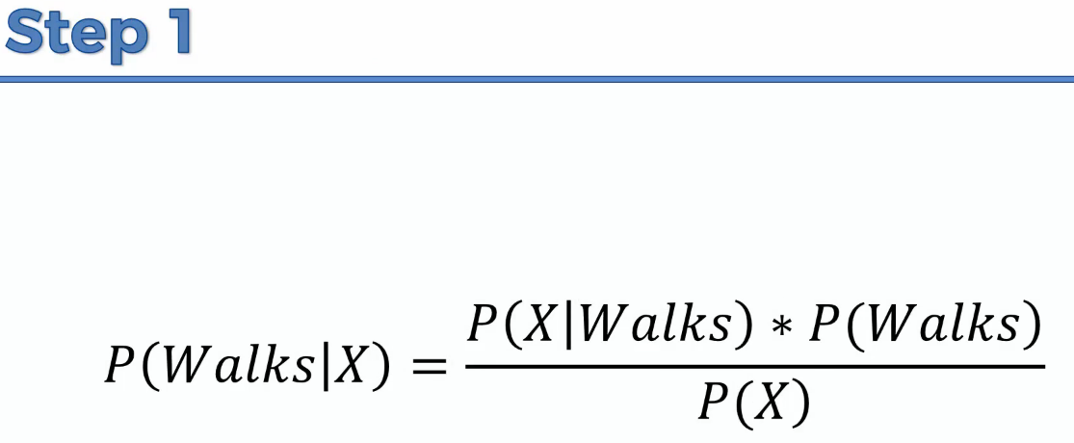

**X🡪features or independent variable.**

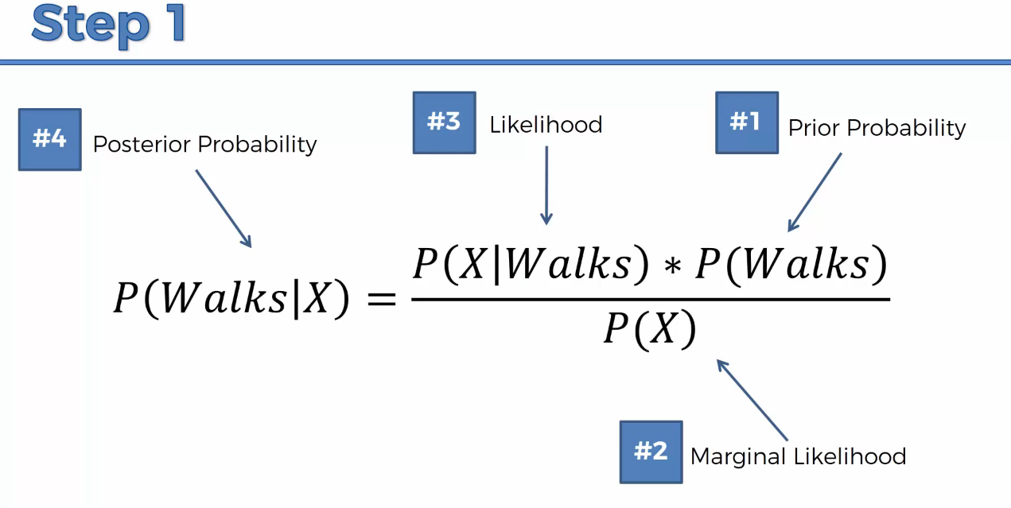

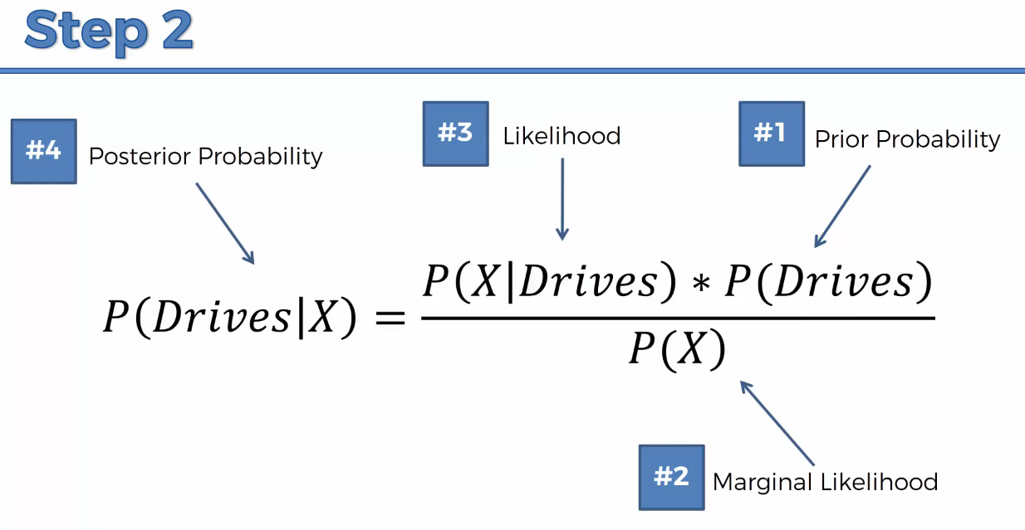

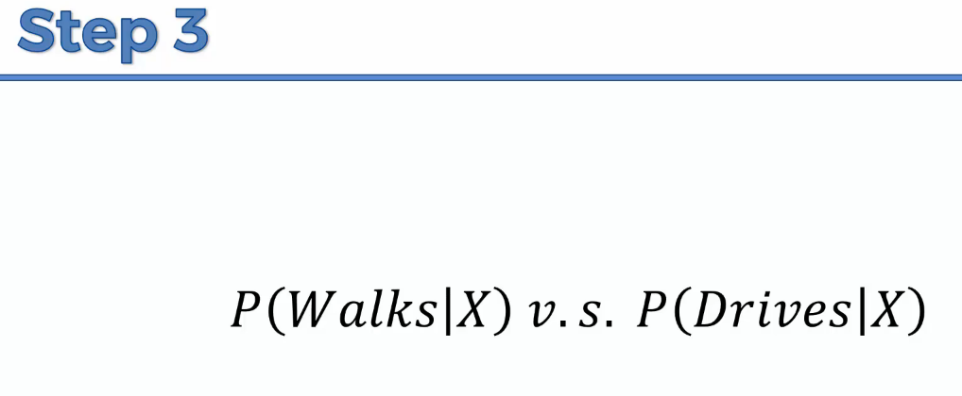

**Solution:**

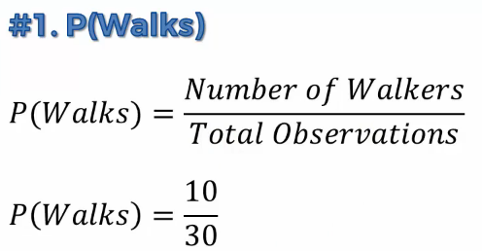

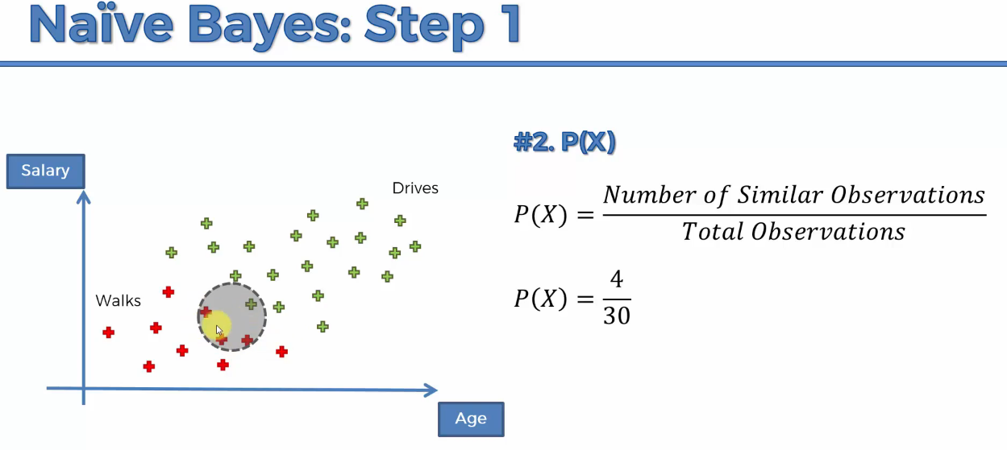

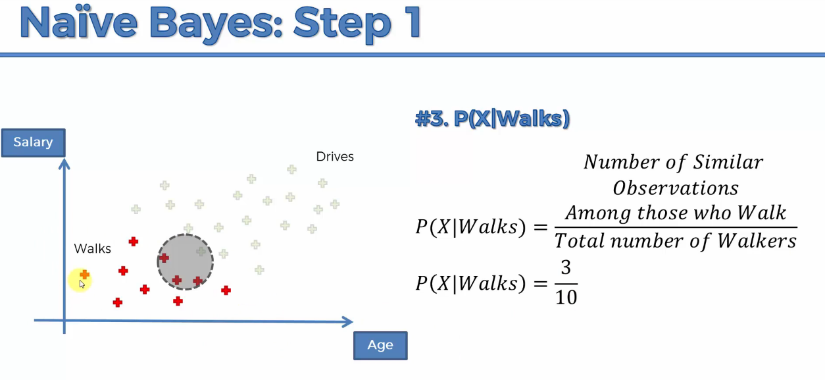

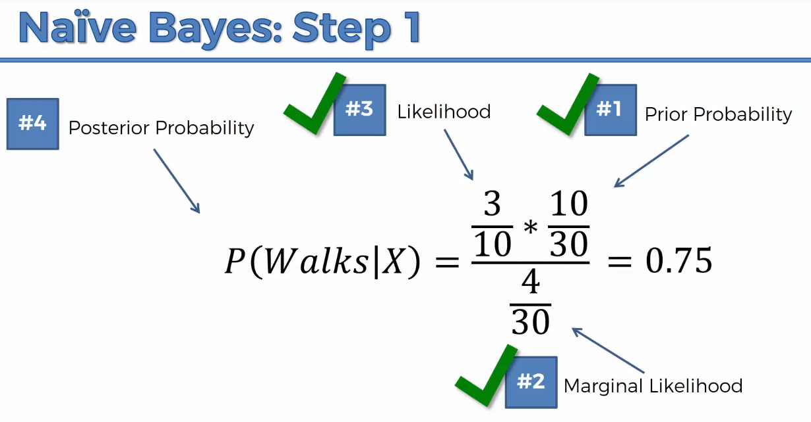

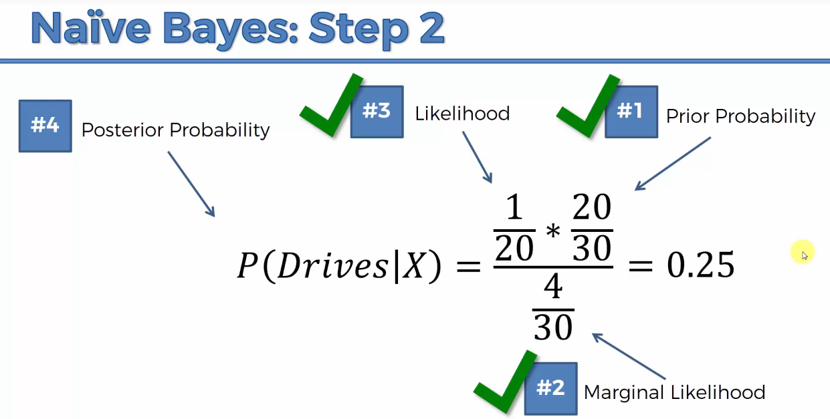

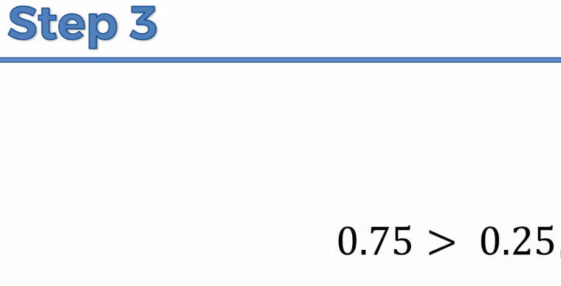

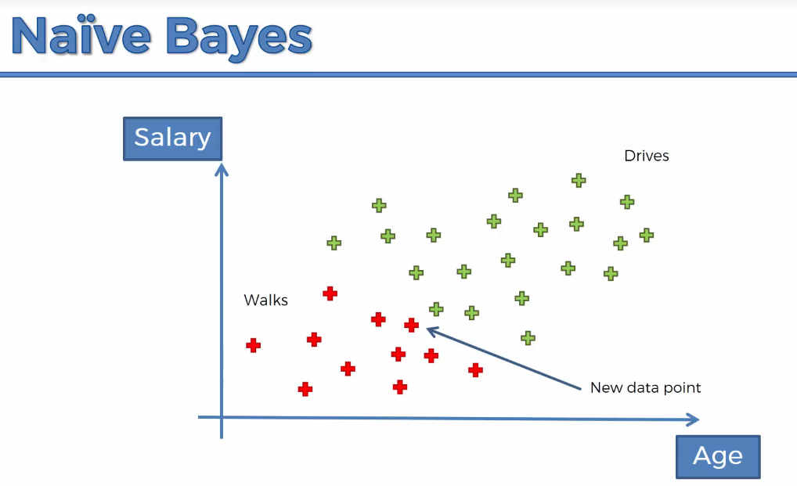

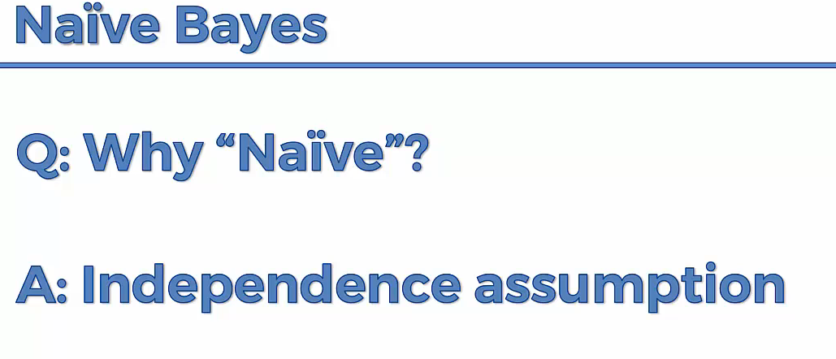

**Salary and Age should be independent. But as age increases, salary also increases. There is co-relation.**

**P(X) does not change,**

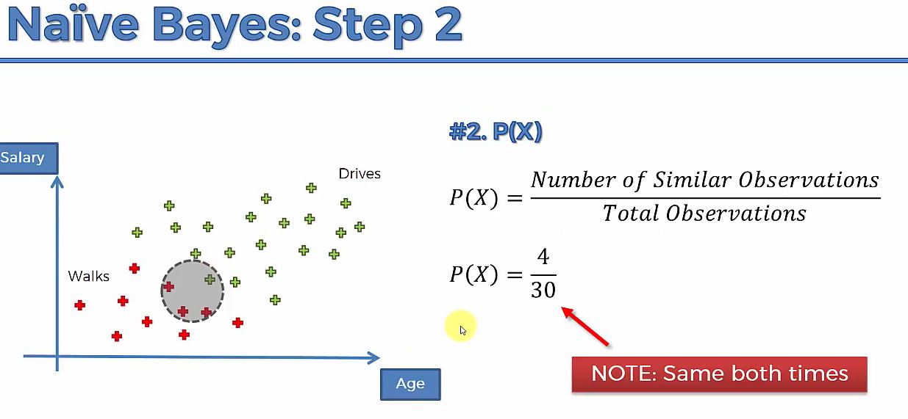

**Only if we compare the result, the below step is valid.**

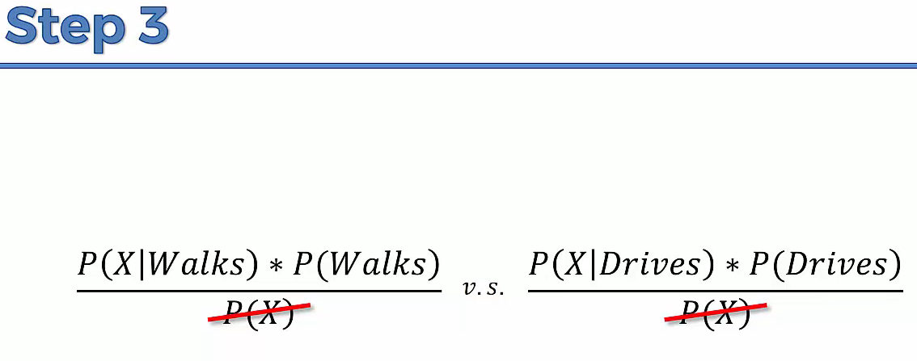



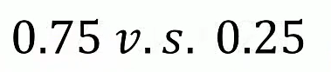



**The probability of every classes is found and the result is compared.**

**Result:**

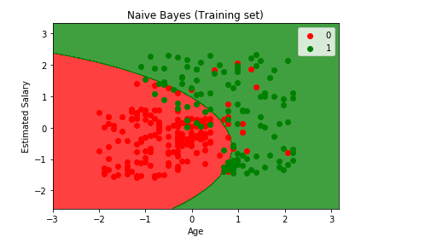

**we are getting smooth curve.**

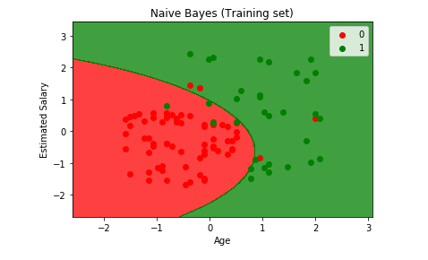

**Decision Tree –Classification**

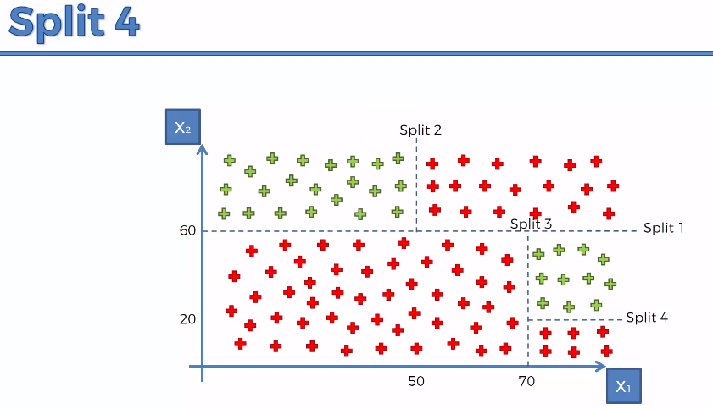

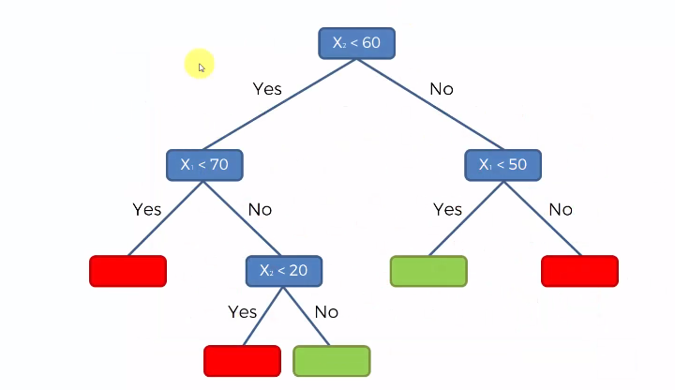

**It can handle multi-dimensional attribute**

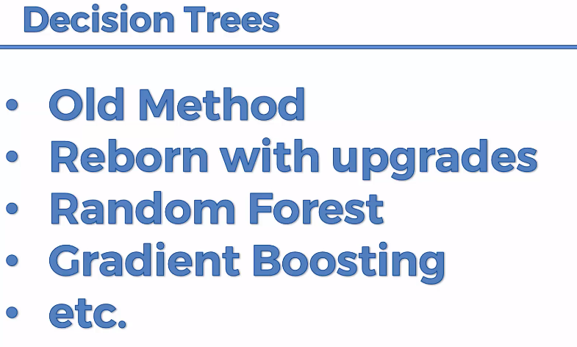

**Random Forest used in Image classification in phone and x-box movement while playing games.**

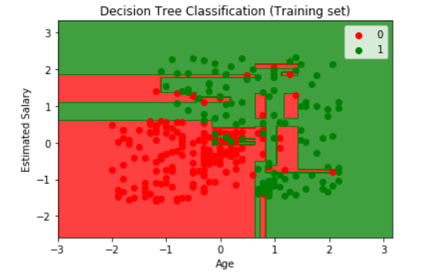

**Ensemble🡪When you take multiple machine learning to create a new machine learning model. Decision tree is clubbed to make random forest model.**

**Random Forest Classification:**

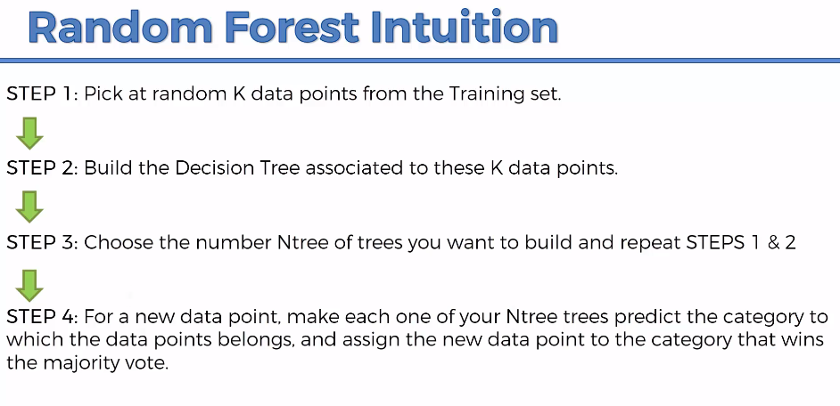

**It uses the power of crowd. To remove certain error and increase the accuracy.**

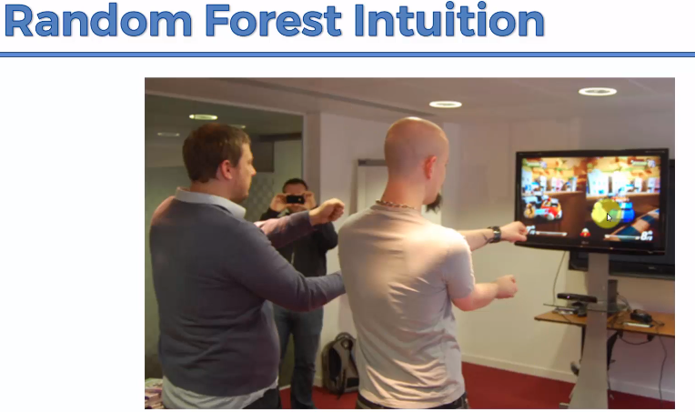

**X-Box used Random Forest.because it increases the processing speed with less hardware cost.**

**#no.of.tree is more some time can results in over-fitting on training dataset**

**n_estimators 🡪for each user there will be n_estimators trees, then the majority vote from the n_estimator tree is considered by the machine and it will classify.**

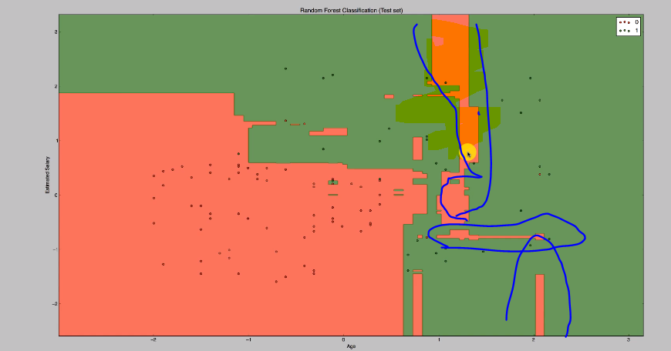

**The highlighted area is overfitted based on the training data set.**

**False Positives and Negatives**

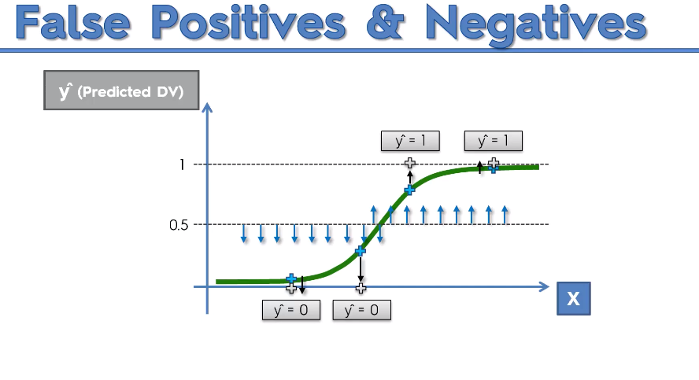

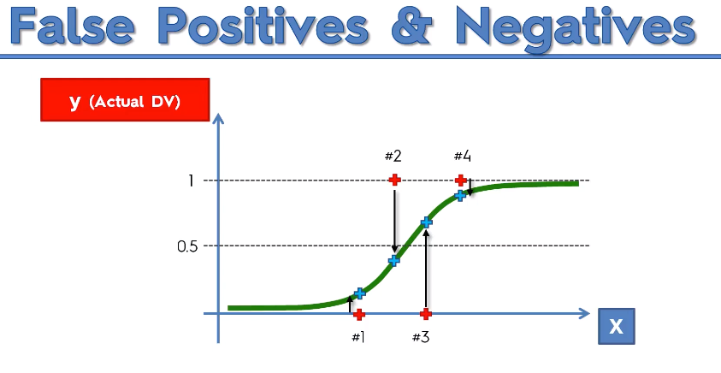

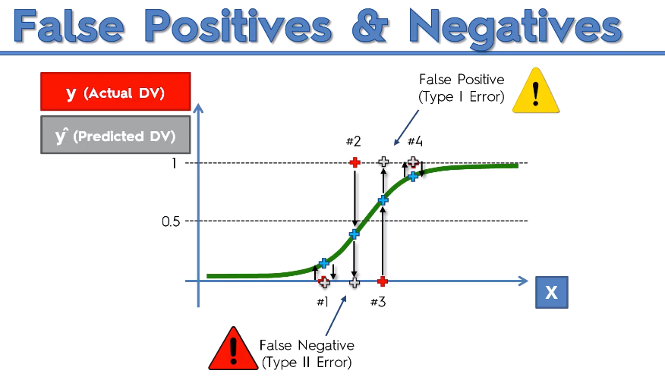

**(2)False(result) Negative(pred)🡪 no cancer but there was cancer🡪dangerous**

**(Negative(0) result but we predicted in a False way-opposite to result)**

**(3)False(pred) Positive(result)🡪 cancer exist but no predicted cancer🡪 Warning**

**(Positive(1) result but we predicted in a False way- opposite to result)**

**(4)True Positive🡪Cancer exists, we found it out there was cancer**

**(Positive(1) result but we predicted in a True way-match to result)**

**(1)True Negative🡪 NO cancer, we found out there was no cancer**

**(Negative(0) result but we predicted in a False way-match to result)**

**Negative, positive-🡪 0,1 vice-versa like yes or no**

**False, True🡪 Prediction result**

**Confusion Matrix**

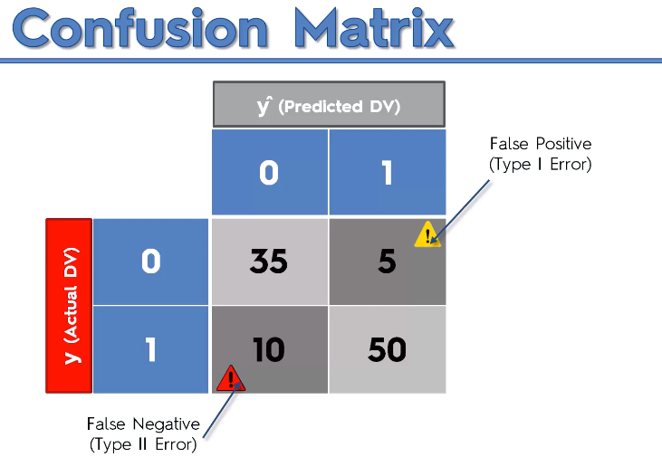

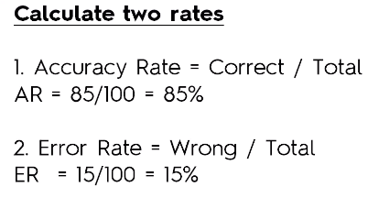

**Accuracy Paradox**

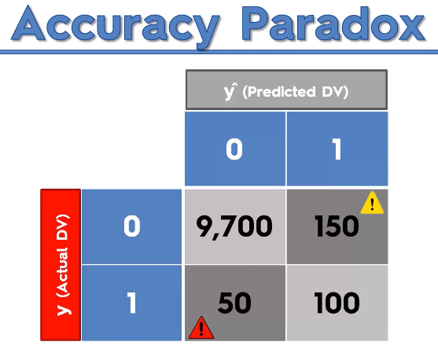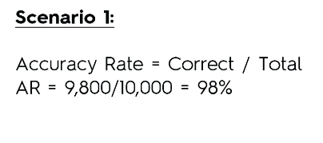

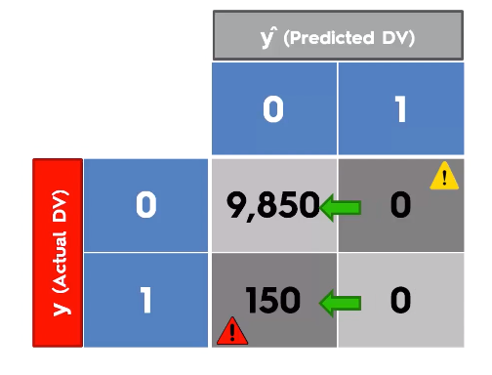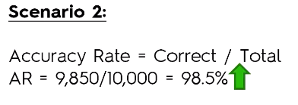

**You should not blindly follow the accuracy. It might miss lead the model.**

**CAP**

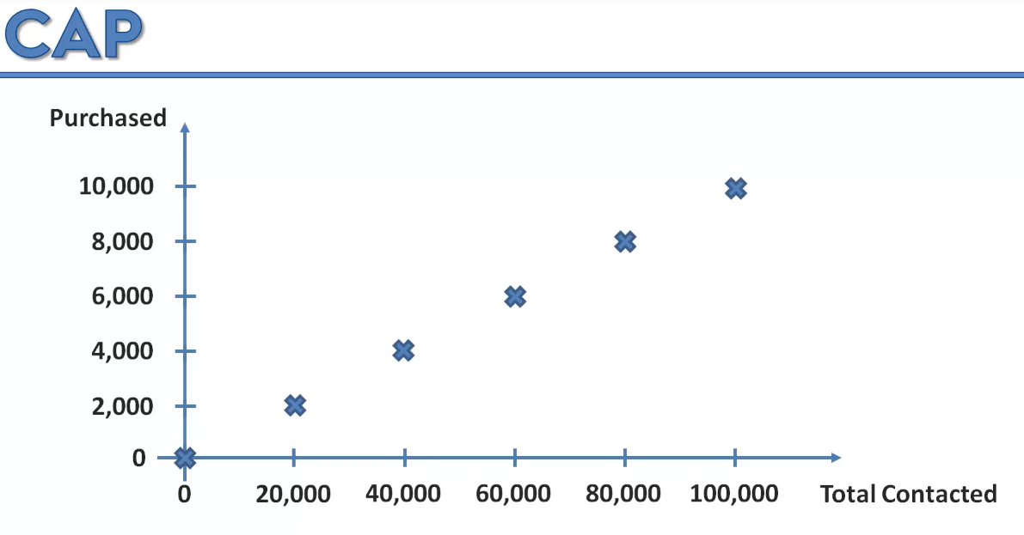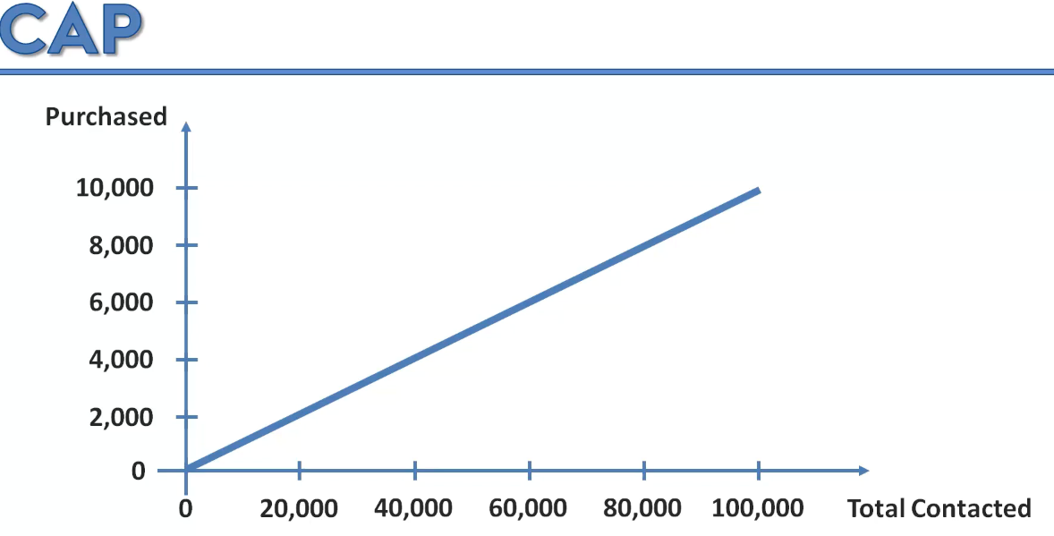

**Instead of sending randomly, we can choose the customer and build the model and target based upon the age, country, salary, interest.**

**Find the likelihood of their purchase.**

**After building the model for our dataset, it will reduce advertisement cost.**

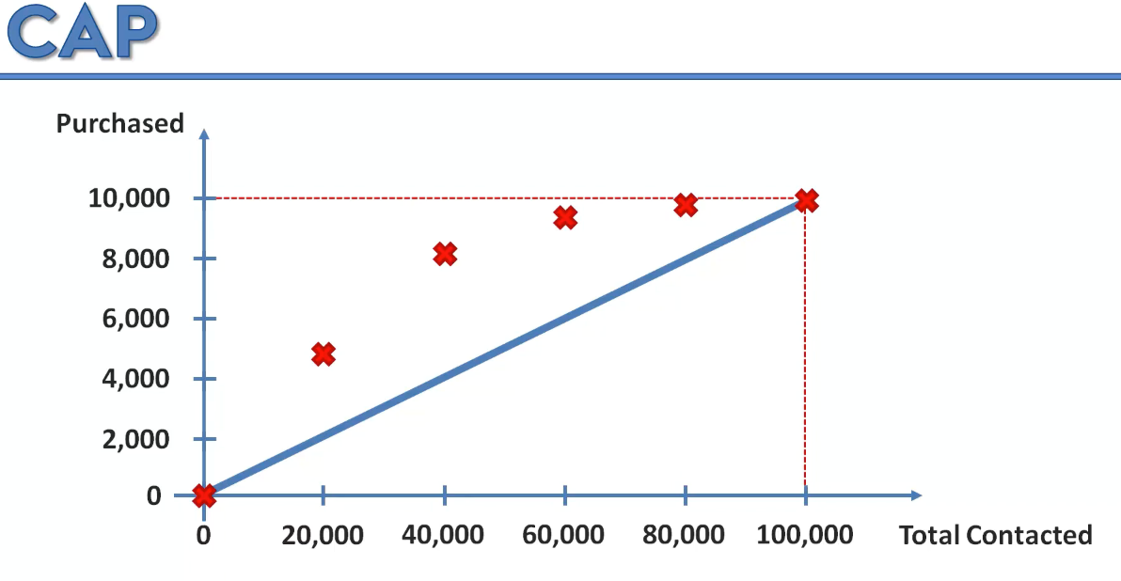

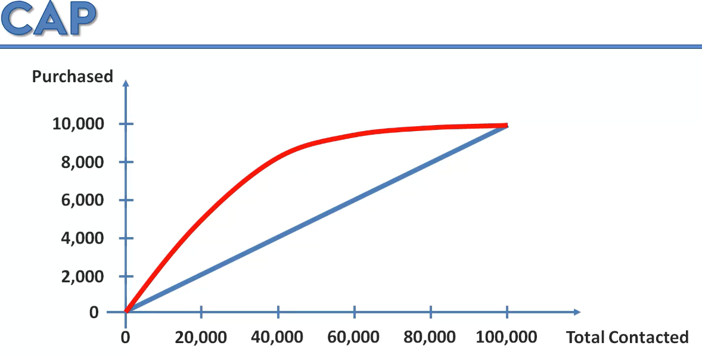

**If it is more away from blue line then the model is good.**

**CAP🡪 it is also called as gain chart by comparing with other model.**

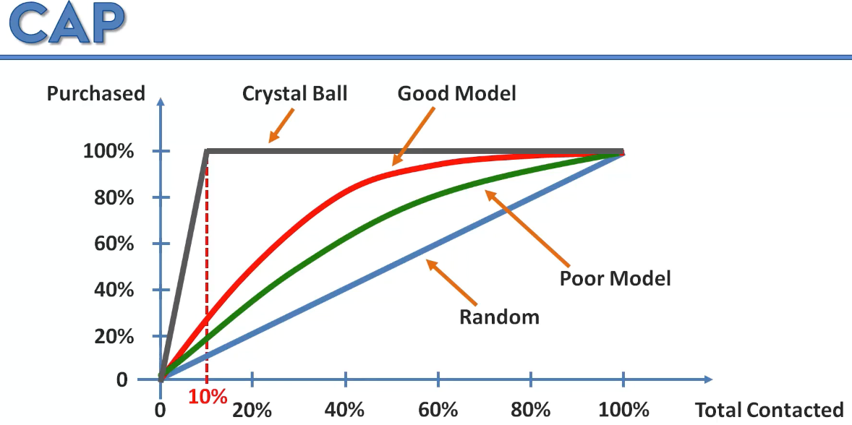

**All the 10 % will buy the product. With less contact more purchase.**

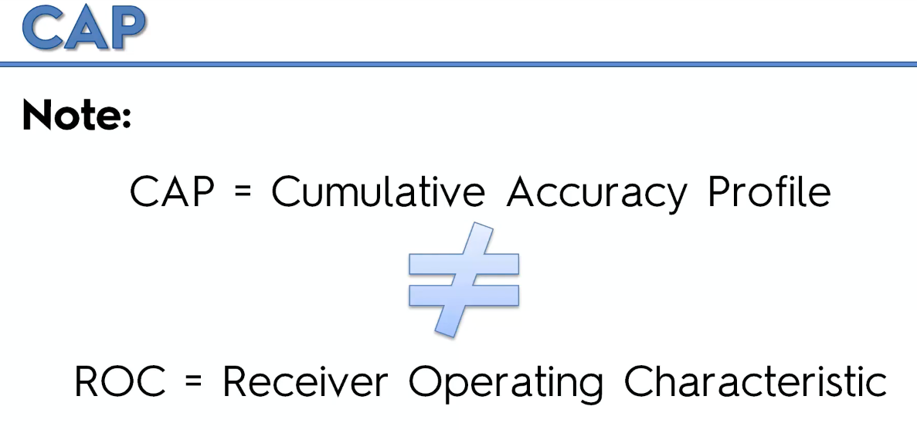

**Cap Analysis:**

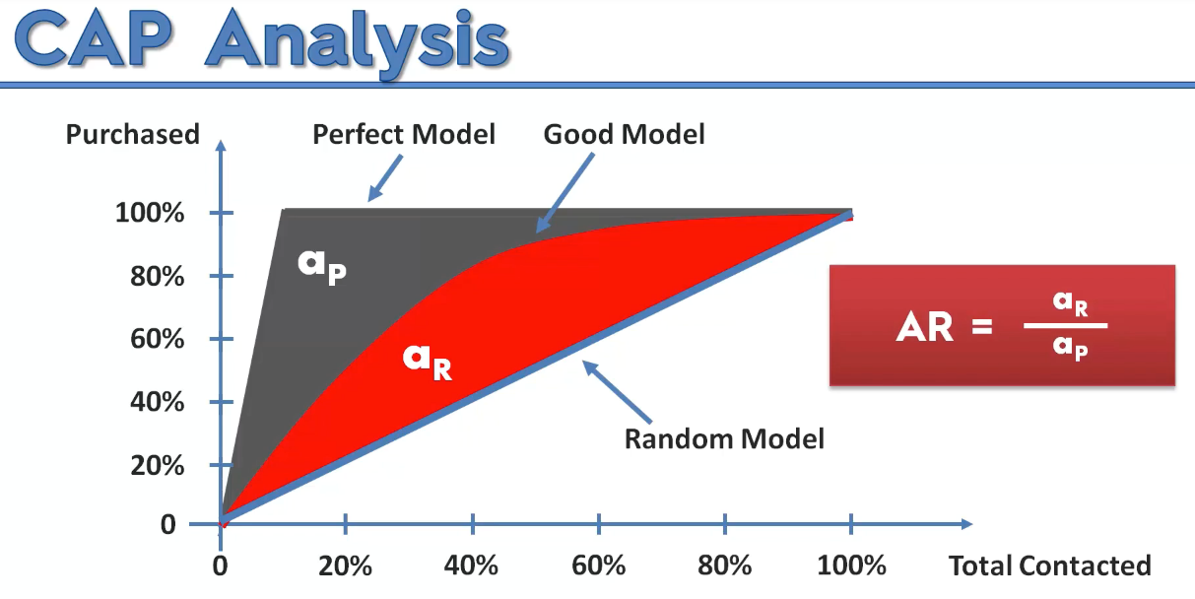

**Closer to 1 is good. Closer to 0 is bad.**

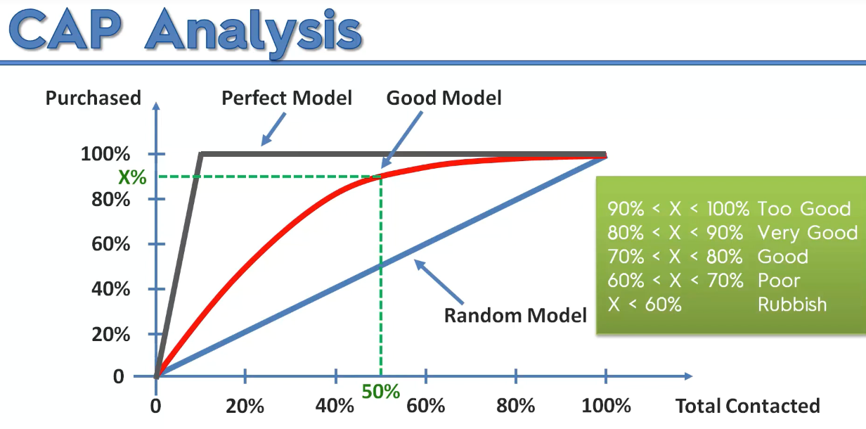

**90%-100% beware of over fitting.**